

Project Health Website

Name Zahid sher khan

Date July 26, 2022

Project Abstract: This is a health website which involves.

1: a blog of wide range of health information.

2: Information related to different health issues.

3: Small health tips.

4: A wide variety of doctors where you can consult the doctor of your choice.

5: Contact us page.

WEBSITE INTERFACE SNAPSHOTS :

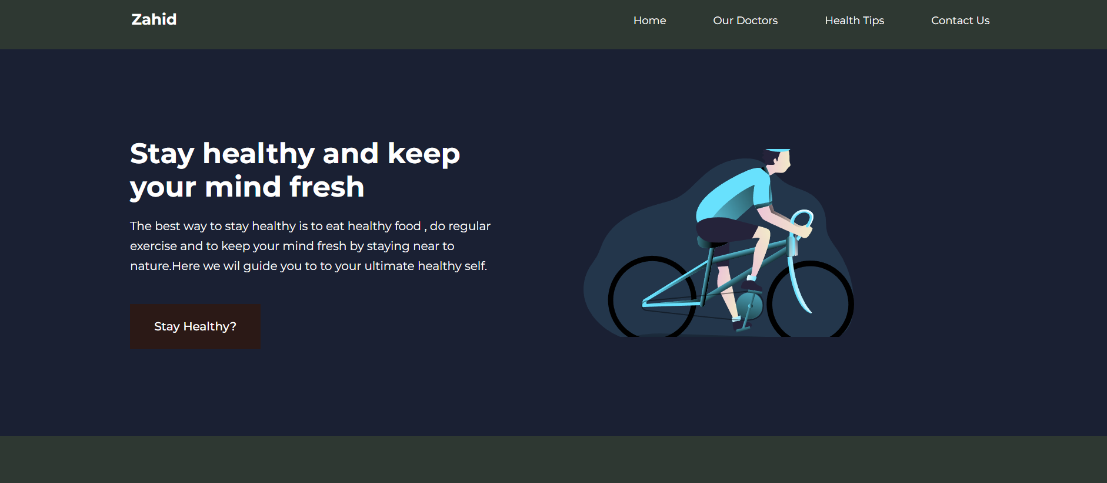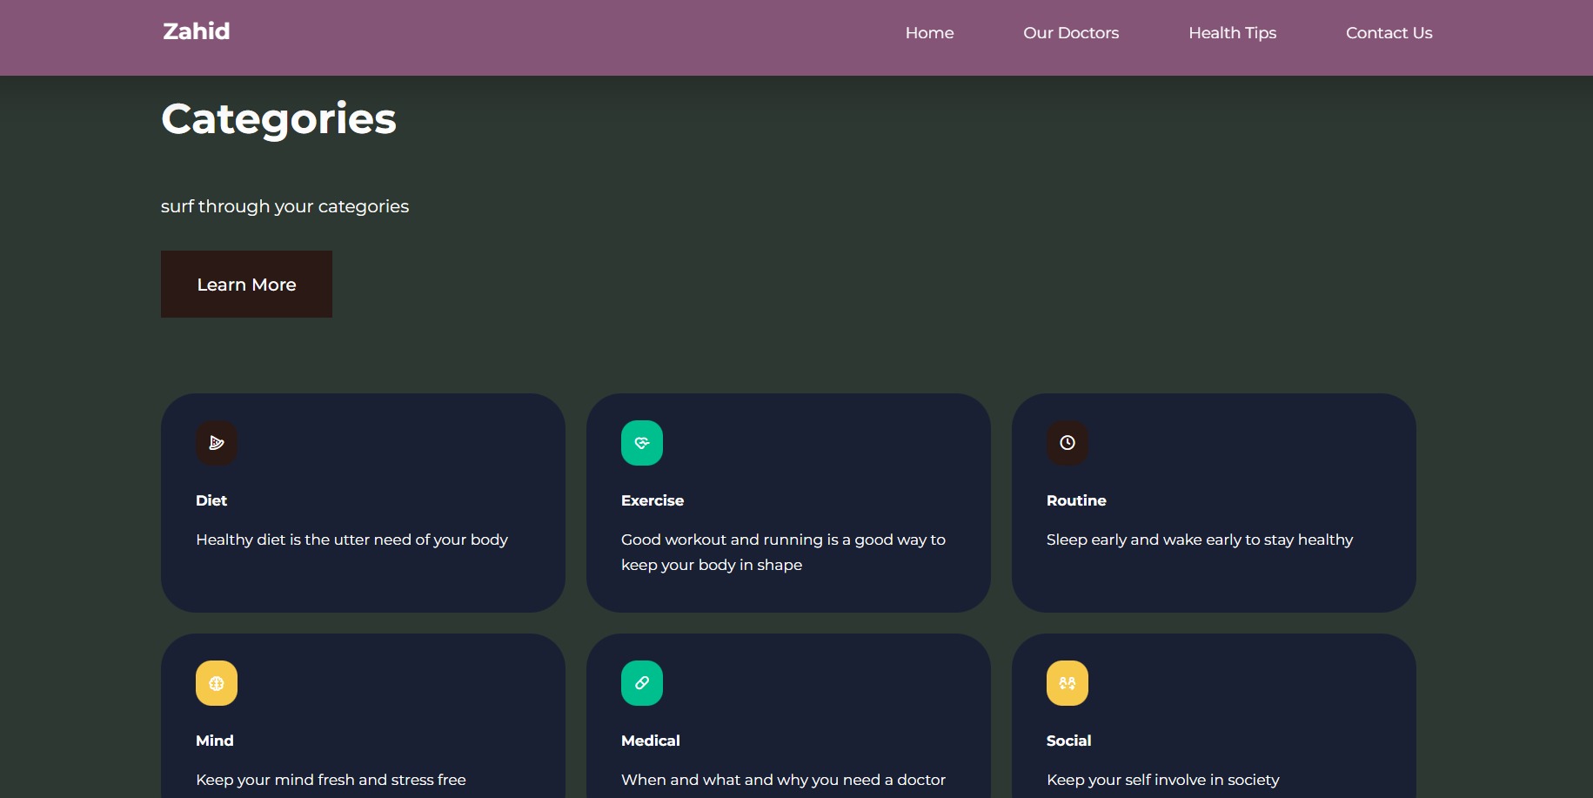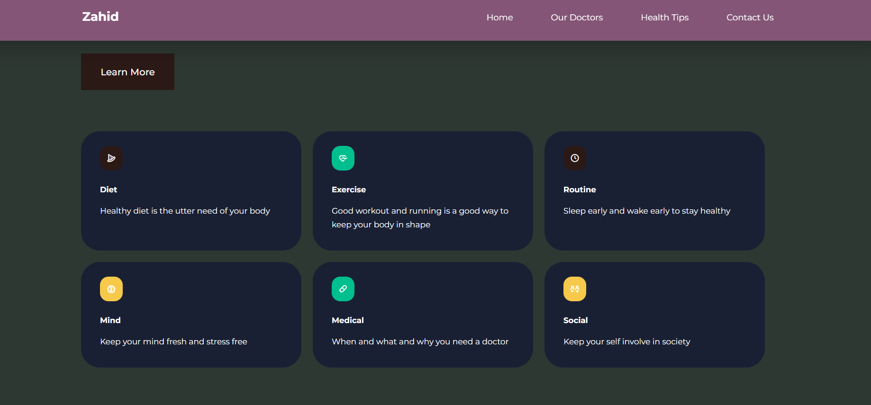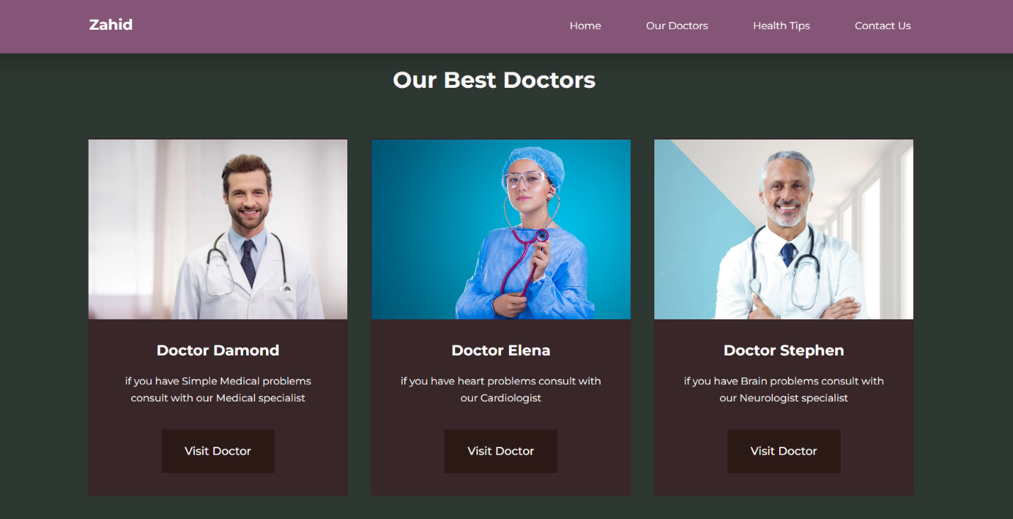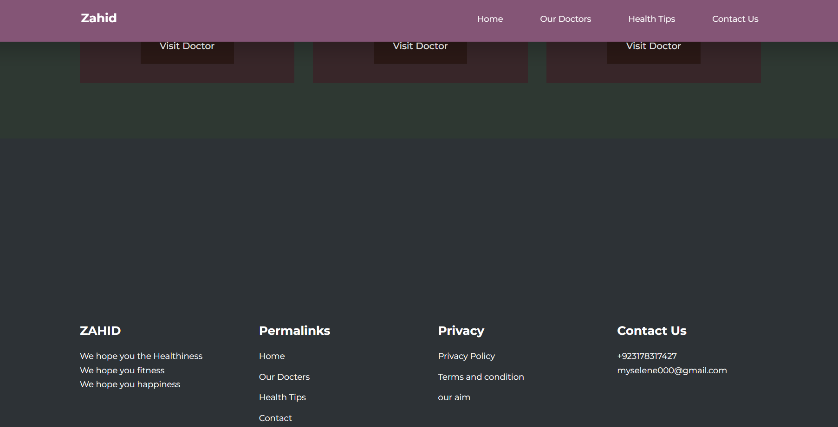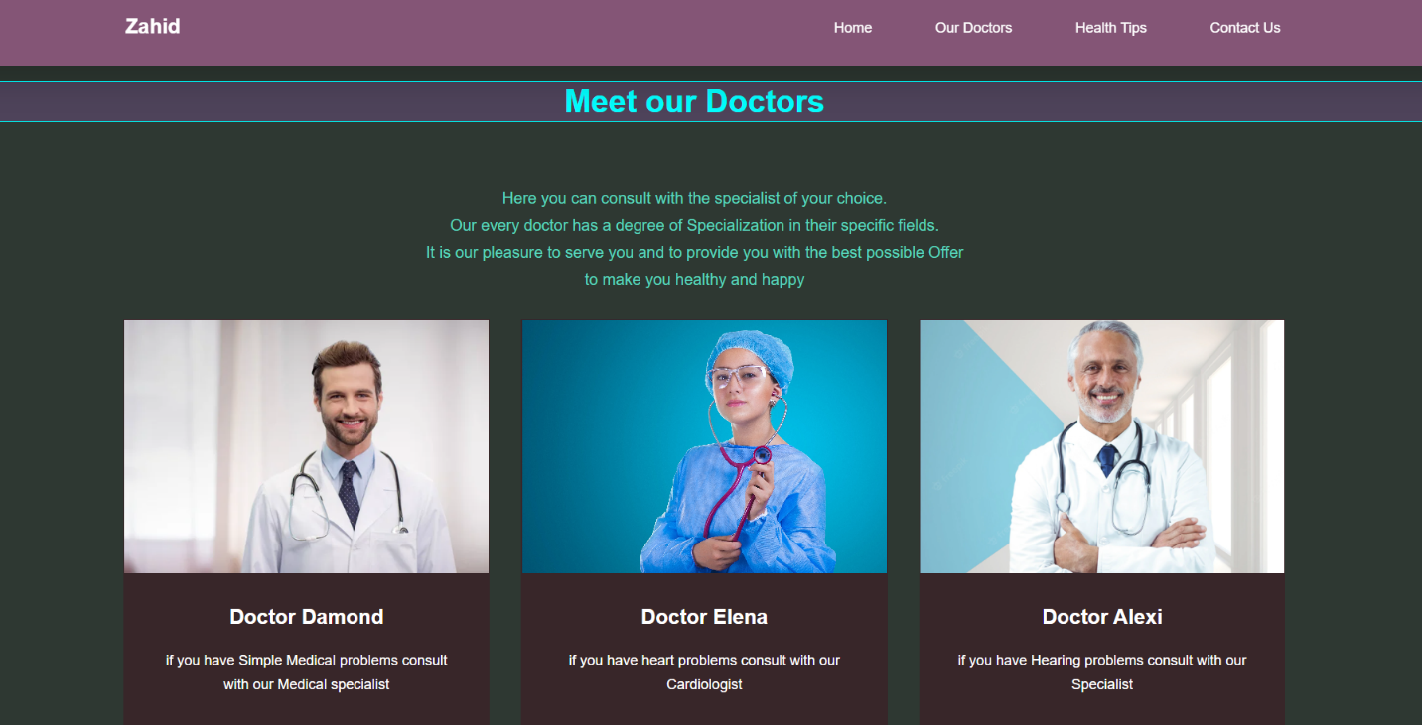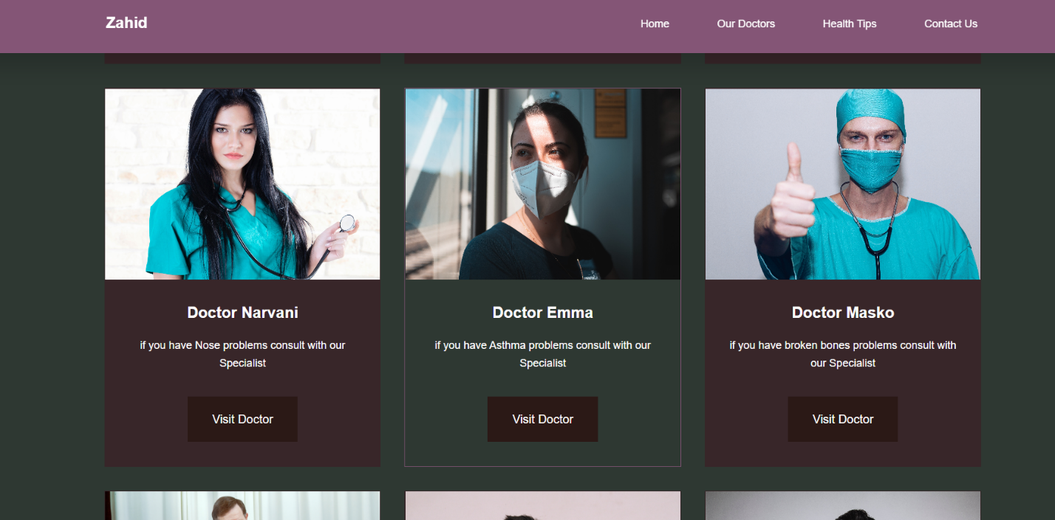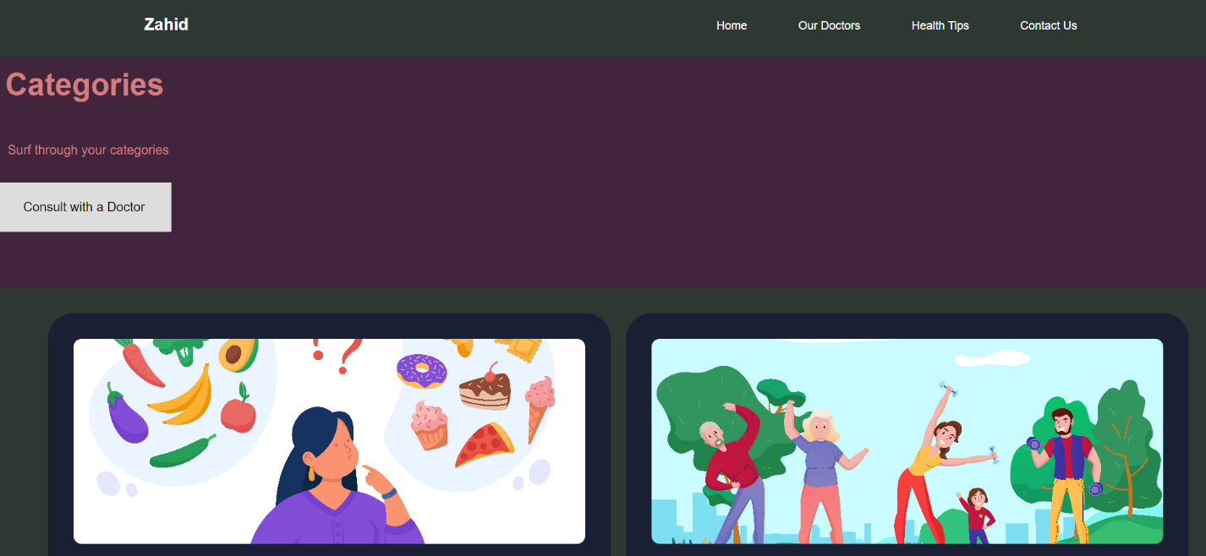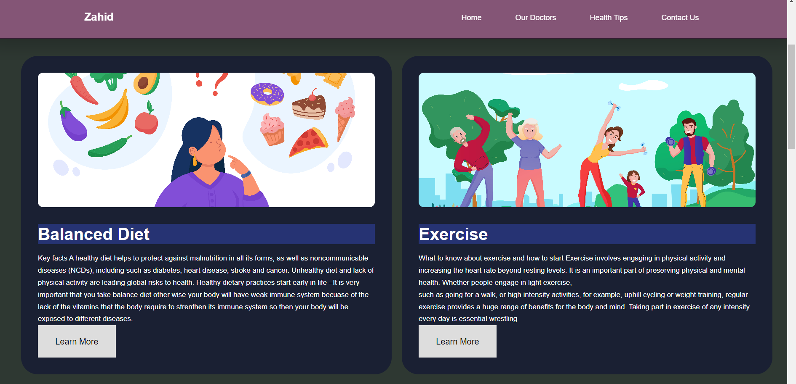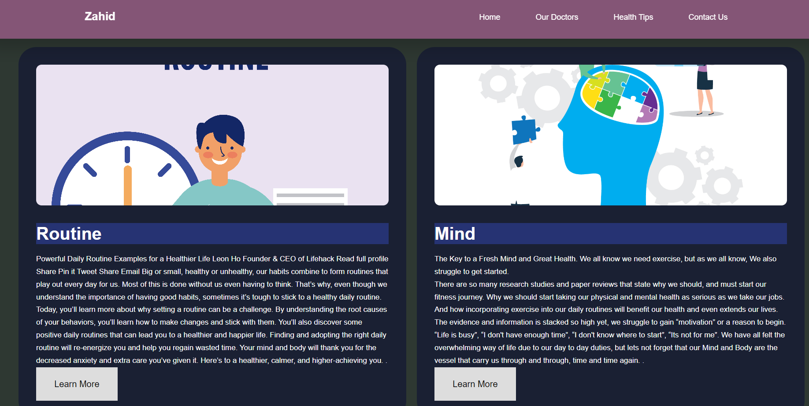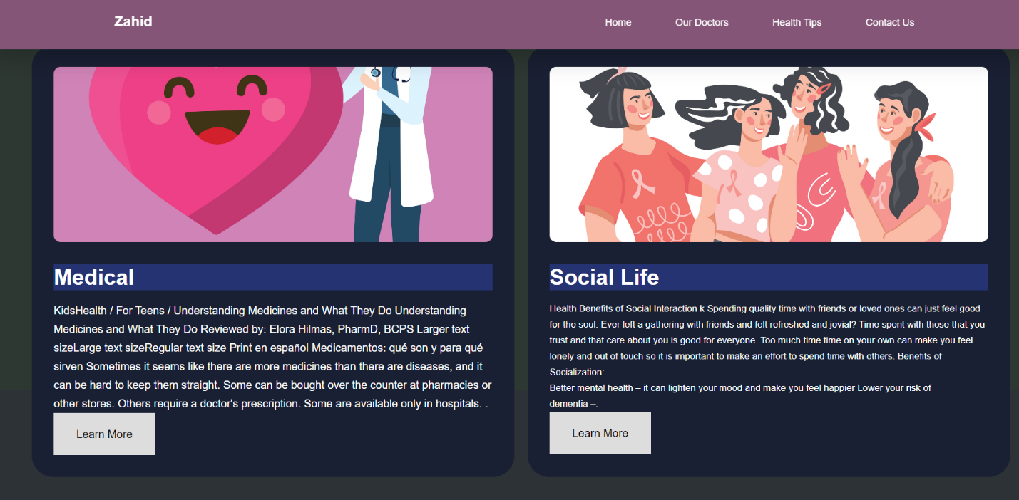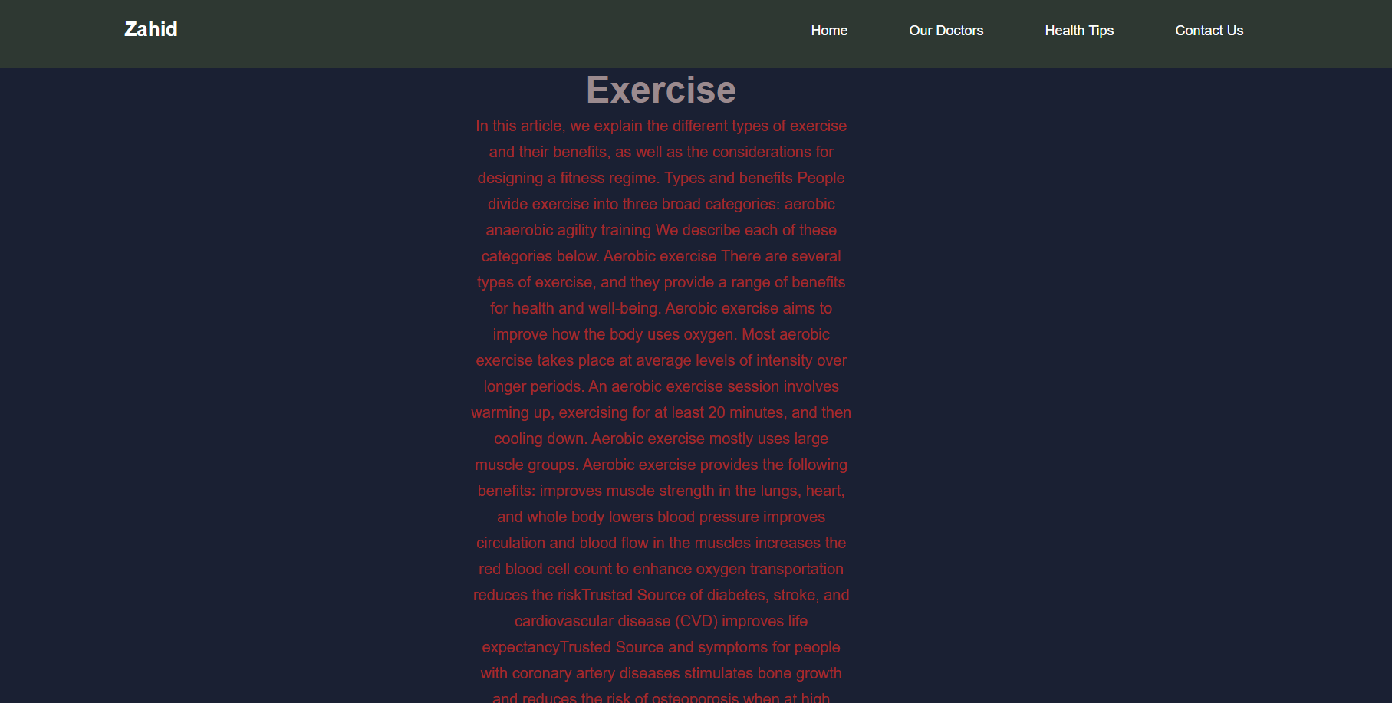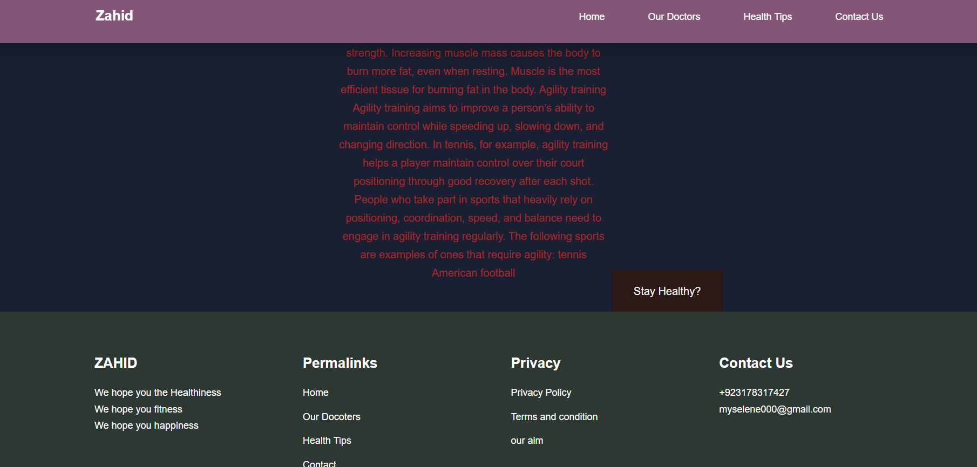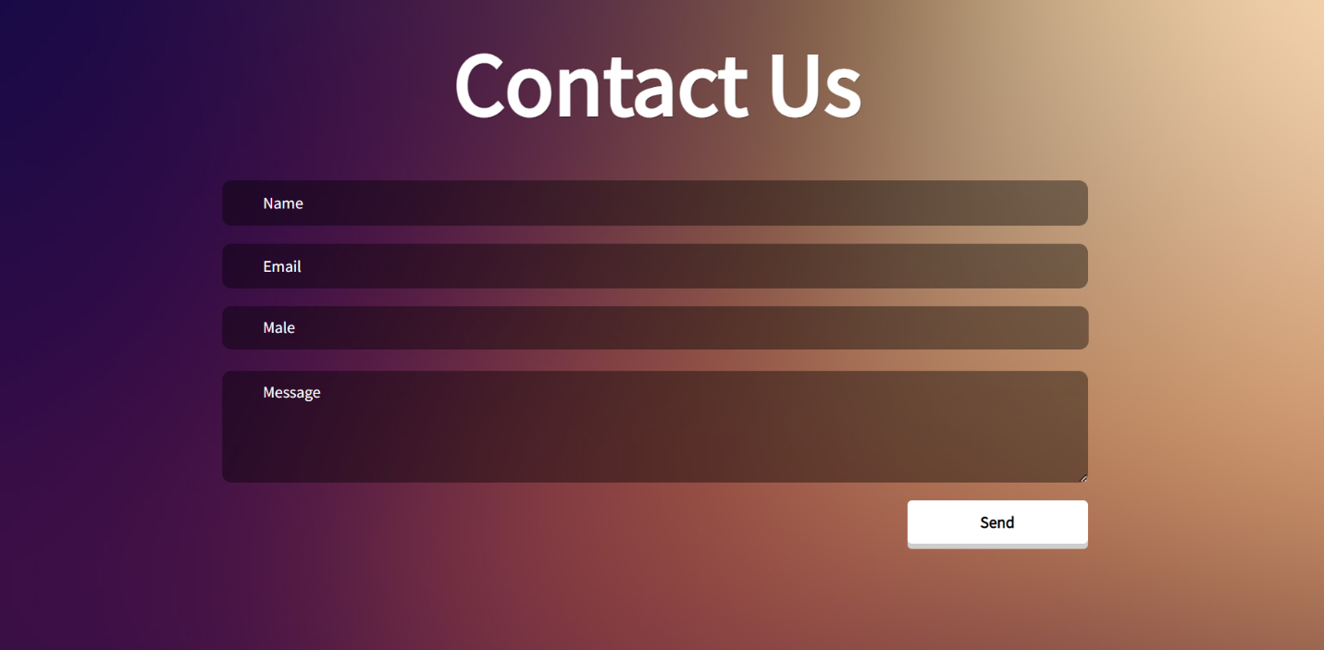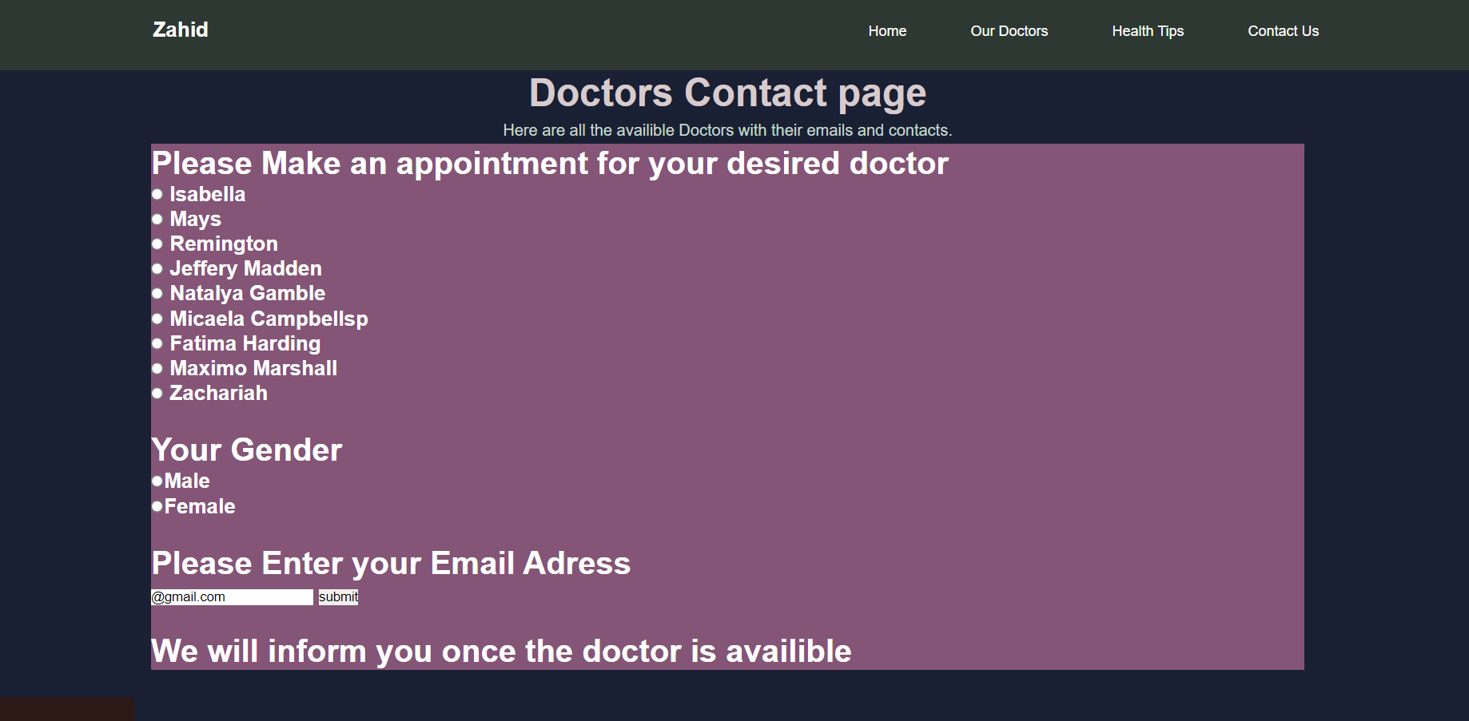

Coding of the WEBSITE:

index.php

<!DOCTYPE html>

<html lang="en">

<head>

<meta charset="UTF-8">

<meta http-equiv="X-UA-Compatible" content="IE=edge">

<meta name="viewport" content="width=device-width, initial-scale=1.0">

<title>Health Website

</title>

<link rel="stylesheet" href="./css/style.css">

<!-- ICONSCOUT CDN -->

<link rel="stylesheet" href="https://unicons.iconscout.com/release/v4.0.0/css/line.css">

<!-- Google fonts --><link rel="preconnect" href="https://fonts.googleapis.com">

<link rel="preconnect" href="https://fonts.gstatic.com" crossorigin>

<link href="https://fonts.googleapis.com/css2?family=Montserrat:wght@300;400;500;600;700;800;900&display=swap" rel="stylesheet">

<script src="main.js"></script>

</head>

<body>

<nav class="nav li">

<div class="container nav__container">

<a href="index.php"><h4>Zahid</h4></a>

<ul class="nav__menu">

<li><a href="index.php">Home</a></li>

<li><a href="doctors.php">Our Doctors</a></li>

<li><a href="health.php">Health Tips</a></li>

<li><a href="contact.php">Contact Us</a></li>

</ul>

<button id="open-menu-btn"><i class="uil uil-bars"></i></button>

<button id="close-menu-btn"><i class="uil uil-multiply"></i></button>

</div>

</nav>

<!-- ==================================End of navbar ===================================--->

<header>

<div class="container header__container">

<div class="header__left">

<h1>Stay healthy and keep your mind fresh</h1>

<p>The best way to stay healthy is to eat healthy food , do regular exercise

and to keep your mind fresh by staying near to nature.Here we wil guide you to to your ultimate healthy self.

</p>

<a href="health.php" class="btn btn-primary">Stay Healthy?</a>

</div>

<div class="header__right-image"><img src="./images/bike.svg">

</div>

</div>

</div>

</header>

<!-- ======================The end of header =============================-->

<section class="categories">

<div class="container categories__container">

<div class="categories left">

<h1>Categories</h1>

<p>surf through your categories<br><br></p>

<a href="health.php" class="btn">Learn More</a>

</div>

<div class="categories__right">

<article class="category">

<span class="category__icon">

<i class="uil uil-pizza-slice"></i>

</span>

<h5>Diet</h5>

<p>Healthy diet is the utter need of your body</p>

</article>

<article class="category">

<span class="category__icon">

<i class="uil uil-heartbeat"></i>

</span>

<h5>Exercise</h5>

<p>Good workout and running is a good way to keep your body in shape</p>

</article>

<article class="category">

<span class="category__icon">

<i class="uil uil-clock"></i>

</span>

<h5>Routine</h5>

<p>Sleep early and wake early to stay healthy</p>

</article>

<article class="category">

<span class="category__icon">

<i class="uil uil-brain"></i>

</span>

<h5>Mind</h5>

<p>Keep your mind fresh and stress free</p>

</article>

<article class="category">

<span class="category__icon">

<i class="uil uil-capsule"></i>

</span>

<h5>Medical</h5>

<p>When and what and why you need a doctor</p>

</article>

<article class="category">

<span class="category__icon">

<i class="uil uil-social-distancing"></i>

</span>

<h5>Social</h5>

<p>Keep your self involve in society</p>

</article>

</div>

</div>

</section>

<!-- ==========================End of categories================= -->

<!-- ==========================Our best Doctors================== -->

<section class="courses">

<h2>Our Best Doctors</h2>

<div class="container courses__container">

<article class="course">

<div class="course__image">

<img src="./images/doctor1.jpg" alt="">

</div>

<div class="course__info">

<h4>Doctor Damond</h4>

<p>if you have Simple Medical problems consult with our Medical specialist</p>

<a href="doctorvisit.php" class="btn btn-primary">Visit Doctor</a>

</div>

</article>

<article class="course">

<div class="course__image">

<img src="./images/doctor2.jpg" alt="">

</div>

<div class="course__info">

<h4>Doctor Elena</h4>

<p>if you have heart problems consult with our Cardiologist</p>

<a href="doctorvisit.php" class="btn btn-primary">Visit Doctor</a>

</div>

</article>

<article class="course">

<div class="course__image">

<img src="./images/1Capture.PNG" alt="">

</div>

<div class="course__info">

<h4>Doctor Stephen</h4>

<p>if you have Brain problems consult with our Neurologist specialist</p>

<a href="doctorvisit.php" class="btn btn-primary">Visit Doctor</a>

</div>

</article>

</div>

</section>

<!-- =============================end of our best doctors============= -->

<!-- ======================footer====================================== -->

<footer class="footer">

<div class="container footer__container">

<div class="footer__1">

<a href="index.php" class="footer__logo"><h4>ZAHID</h4></a>

<p>We hope you the Healthiness<br>We hope you fitness<br>We hope you happiness</p>

</div>

<div class="footer__2">

<h4>Permalinks</h4>

<ul class="permalinks">

<li><a href="index.php">Home</a></li>

<li><a href="doctors.php">Our Docters</a></li>

<li><a href="health.php">Health Tips</a></li>

<li><a href="contact.php">Contact</a></li>

</ul>

</div>

<div class="footer__3">

<h4>Privacy</h4>

<ul class="privacy">

<li><a href="#">Privacy Policy</a></li>

<li><a href="#">Terms and condition</a></li>

<li><a href="#">our aim</a></li>

</ul>

</div>

<div class="footer__4">

<h4>Contact Us</h4>

<div>

<p>+923178317427</p>

<p>myselene000@gmail.com</p>

</div>

</div>

</div>

</footer>

<!-- =============================--end of footer=============== -->

social.php

</body>

</html>

<!DOCTYPE html>

<html lang="en">

<head>

<meta charset="UTF-8">

<meta http-equiv="X-UA-Compatible" content="IE=edge">

<meta name="viewport" content="width=device-width, initial-scale=1.0">

<title>Health Website

</title>

<link rel="stylesheet" href="./css/tips.css">

<!-- ICONSCOUT CDN -->

<link rel="stylesheet" href="https://unicons.iconscout.com/release/v4.0.0/css/line.css">

<!-- Google fonts --><link rel="preconnect" href="https://fonts.googleapis.com">

<link rel="preconnect" href="https://fonts.gstatic.com" crossorigin>

<link href="https://fonts.googleapis.com/css2?family=Montserrat:wght@300;400;500;600;700;800;900&display=swap" rel="stylesheet">

<script src="main.js"></script>

</head>

<body>

<nav class="nav li">

<div class="container nav__container">

<a href="index.html"><h4>Zahid</h4></a>

<ul class="nav__menu">

<li><a href="index.php">Home</a></li>

<li><a href="doctors.php">Our Doctors</a></li>

<li><a href="health.php">Health Tips</a></li>

<li><a href="contact.php">Contact Us</a></li>

</ul>

<button id="open-menu-btn"><i class="uil uil-bars"></i></button>

<button id="close-menu-btn"><i class="uil uil-multiply"></i></button>

</div>

</nav>

<header>

<div id="special">

<h1 style= "text-align:center; color: rgb(155, 138, 142);">Social-Life</h1>

<p style="text-align:center;color:brown ;"> social interaction is good for your brain health

Promotes a sense of safety, belonging and security

Allows you to confide in others and let them confide in you

In-Person Connections

Social networks and online interactions may give people a false sense of connectedness. We still need physic in-person connections for our own mental health. Schedule time with friends (in-person) on a regular basis to avoid loneliness. It doesn’t have to be a full night out. It could be a 15 minute walk with a neighbor or meeting up for a quick coffee.

Your Circle

Your default peer group is at work and relationships at work are important, but relationships outside work are important too. Relationships with neighbors, the parents of your kids’ friends, or others that share common interests with you are good for your well-being. Take a second to evaluate the people you spend time with and look for ways to branch out if that circle doesn’t go beyond colleagues.

Feeling lonely or looking for ways to grow your circle? Contact your EAP provider

</p></p>

<br> </div>

<a href="health.html" class="btn btn-primary">Stay Healthy?</a>

</div>

</div>

</div></div>

</header>

<footer class="footer">

<div class="container footer__container">

<div class="footer__1">

<a href="index.php" class="footer__logo"><h4>ZAHID</h4></a>

<p>We hope you the Healthiness<br>We hope you fitness<br>We hope you happiness</p>

</div>

<div class="footer__2">

<h4>Permalinks</h4>

<ul class="permalinks">

<li><a href="index.php">Home</a></li>

<li><a href="doctors.php">Our Docoters</a></li>

<li><a href="health.php">Health Tips</a></li>

<li><a href="contact.php">Contact</a></li>

</ul>

</div>

<div class="footer__3">

<h4>Privacy</h4>

<ul class="privacy">

<li><a href="#">Privacy Policy</a></li>

<li><a href="#">Terms and condition</a></li>

<li><a href="#">our aim</a></li>

</ul>

</div>

<div class="footer__4">

<h4>Contact Us</h4>

<div>

<p>+923178317427</p>

<p>myselene000@gmail.com</p>

</div>

</div>

</div>

</footer>

</body>

</html>

Routine.php

<!DOCTYPE html>

<html lang="en">

<head>

<meta charset="UTF-8">

<meta http-equiv="X-UA-Compatible" content="IE=edge">

<meta name="viewport" content="width=device-width, initial-scale=1.0">

<title>Health Website

</title>

<link rel="stylesheet" href="./css/tips.css">

<!-- ICONSCOUT CDN -->

<link rel="stylesheet" href="https://unicons.iconscout.com/release/v4.0.0/css/line.css">

<!-- Google fonts --><link rel="preconnect" href="https://fonts.googleapis.com">

<link rel="preconnect" href="https://fonts.gstatic.com" crossorigin>

<link href="https://fonts.googleapis.com/css2?family=Montserrat:wght@300;400;500;600;700;800;900&display=swap" rel="stylesheet">

<script src="main.js"></script>

</head>

<body>

<nav class="nav li">

<div class="container nav__container">

<a href="index.php"><h4>Zahid</h4></a>

<ul class="nav__menu">

<li><a href="index.php">Home</a></li>

<li><a href="doctors.php">Our Doctors</a></li>

<li><a href="health.php">Health Tips</a></li>

<li><a href="contact.php">Contact Us</a></li>

</ul>

<button id="open-menu-btn"><i class="uil uil-bars"></i></button>

<button id="close-menu-btn"><i class="uil uil-multiply"></i></button>

</div>

</nav>

<header>

<div id="special">

<h1 style= "text-align:center; color: rgb(155, 138, 142);">Routine</h1>

<p style="text-align:center;color:brown ;">

Today, you’ll learn more about why setting a routine can be a challenge. By understanding the root causes of your behaviors, you’ll learn how to make changes and stick with them. You’ll also discover some positive daily routines that can lead you to a healthier and happier life.

Finding and adopting the right daily routine will re-energize you and help you regain wasted time. Your mind and body will thank you for the decreased anxiety and extra care you’ve given it. Here’s to a healthier, calmer, and higher-achieving you.

TABLE OF CONTENTS

How a Daily Routine Changes Your Life<br>

Best Daily Routines for a Healthy Life<br>

Daily Routine for an Organized Life<br>

Daily Routine for More Productive Work<br>

Daily Routine for a Stronger Relationship<br>

How to Stick to Your Routine<br>

More on Building Habits<br>

How a Daily Routine Changes Your Life<br>

Your daily routine consists of all of your habits. These actions structure your day and make the difference between operating at peak efficiency and struggling to make it through a poorly-planned day.

You can have energizing, time-saving routines, or you can adopt draining, inefficient routines. The choice is up to you. Don’t feel bad if you know that some unhealthy habits have crept into your day. The important thing is to recognize them so that you can make a change.

An excellent daily routine sets you up for success. If you make just one change that saves you 10 minutes per day, you can regain 60 hours of your precious time back each year.[1]

Best Daily Routines for a Healthy Life

It takes time to become the best version of yourself, but I’ll help you to make it easier by getting you a few healthy daily routine examples to follow directly.

Daily Routine for Good Health and More Energy

1. Start the Day With a Glass of Lemon Water

Simply add the juice of half a lemon to your glass and drink it to enjoy a refreshing start to the day.

Lemon juice reduces your body’s acidity levels, which, in turn, protects you against inflammatory diseases, such as fungal infections and osteoporosis.[2]

2. Exercise in the Morning

Working out early in the morning improves your energy levels and your circulation, and encourages good lymphatic function. Just 20 or 30 minutes every day can make a difference! Mix up cardio and weights throughout the week for all-over toning and general health.

For great exercises, grab this Cardio Home Workout Plan for free and try the recommended exercises!

Getting on the scale each morning is also an effective way to monitor your weight. Don’t go weeks without weighing yourself, because this allows you to remain in denial about any weight gain.

3. Eat a Good Breakfast

When you eat breakfast, fuel yourself with a healthy mix of protein, slow-release carbohydrates, vitamins, and minerals. Sensible options include yogurt with nuts and berries, a vegetable omelet, and low-sugar granola bars with a piece of fruit.

4. Stay Hydrated

Did you know that becoming even slightly dehydrated can lead to lowered mood and decreased concentration? Keep water or other low-sugar drinks on hand to sip throughout the day.[3]

5. Get a Healthy Lunch

Even the busiest of us can grab a healthy lunch as part of a daily routine. For lunch ideas you can make in advance and take with you to work, check out this post: Healthy Lunch Ideas for Work

Avoid too much fat at lunch time, as it promotes afternoon lethargy, which isn’t going to help you get through a busy day![4]

6. Do Some Mid-Afternoon Stretches

Most of us have a mid-afternoon “slump” somewhere between 2 and 4 PM, but you can keep yourself going through the day by choosing a healthy lunch and doing some light stretches or a bit of exercise in the afternoon. Check out this list of 29 exercises you can do at (or near) your desk.

7. Dinner

With a plethora of meal planning apps out there, getting a quick but healthy dinner on the table has never been easier! Be realistic, and choose something that doesn’t require a lot of time or effort to throw together, otherwise you may resort to takeout.

Green vegetables are always a great choice, as they are packed with antioxidants and have an alkanizing effect. Choose plant-based proteins such as tofu or seitan or, if you prefer animal protein, pick fish and lamb rather than beef or chicken to minimize acidity levels in the body.[5]

Avoid caffeine in the late afternoon and evening, because it will prevent you sleeping soundly at night

</p></p>

<br> </div>

<a href="health.php" class="btn btn-primary">Stay Healthy?</a>

</div>

</div>

</div></div>

</header>

<footer class="footer">

<div class="container footer__container">

<div class="footer__1">

<a href="index.php" class="footer__logo"><h4>ZAHID</h4></a>

<p>We hope you the Healthiness<br>We hope you fitness<br>We hope you happiness</p>

</div>

<div class="footer__2">

<h4>Permalinks</h4>

<ul class="permalinks">

<li><a href="index.php">Home</a></li>

<li><a href="doctors.php">Our Docoters</a></li>

<li><a href="health.php">Health Tips</a></li>

<li><a href="contact.php">Contact</a></li>

</ul>

</div>

<div class="footer__3">

<h4>Privacy</h4>

<ul class="privacy">

<li><a href="#">Privacy Policy</a></li>

<li><a href="#">Terms and condition</a></li>

<li><a href="#">our aim</a></li>

</ul>

</div>

<div class="footer__4">

<h4>Contact Us</h4>

<div>

<p>+923178317427</p>

<p>myselene000@gmail.com</p>

</div>

</div>

</div>

</footer>

</body>

</html>

Mind.php

<!DOCTYPE html>

<html lang="en">

<head>

<meta charset="UTF-8">

<meta http-equiv="X-UA-Compatible" content="IE=edge">

<meta name="viewport" content="width=device-width, initial-scale=1.0">

<title>Health Website

</title>

<link rel="stylesheet" href="./css/tips.css">

<!-- ICONSCOUT CDN -->

<link rel="stylesheet" href="https://unicons.iconscout.com/release/v4.0.0/css/line.css">

<!-- Google fonts --><link rel="preconnect" href="https://fonts.googleapis.com">

<link rel="preconnect" href="https://fonts.gstatic.com" crossorigin>

<link href="https://fonts.googleapis.com/css2?family=Montserrat:wght@300;400;500;600;700;800;900&display=swap" rel="stylesheet">

<script src="main.js"></script>

</head>

<body>

<nav class="nav li">

<div class="container nav__container">

<a href="index.php"><h4>Zahid</h4></a>

<ul class="nav__menu">

<li><a href="index.php">Home</a></li>

<li><a href="doctors.php">Our Doctors</a></li>

<li><a href="health.php">Health Tips</a></li>

<li><a href="contact.php">Contact Us</a></li>

</ul>

<button id="open-menu-btn"><i class="uil uil-bars"></i></button>

<button id="close-menu-btn"><i class="uil uil-multiply"></i></button>

</div>

</nav>

<header>

<div id="special">

<h1 style= "text-align:center; color: rgb(155, 138, 142);">Mind</h1>

<p style="text-align:center;color:brown ;">So let’s commit to making the time & finding a space where our body and mind are free to relax, breathe & get moving.

So as we know, the key and daily antidote for a fresh mind & great physical health is,

Exercise.

All we have to do is figure out how to get started and how to stick to it.

“The daily practice of some physical work does not mean to

take stress on the body, but it is actually the stress relieving

Activity.” - Abou Elmagd, Mohammed *

5 Ways to Get Started

These are the 5 points that we have outlined that will help you get started and motivated to stick to it:

Find out why now & set a goal.

What caused you to want to begin exercising now?

What event occurred that brought this change up right now in your life?

Identifying this will help you in determining the end result that you desire.

When setting your goal, DO NOT SET A S.M.A.R.T. goal. Set a D.U.M.B. Goal. Reference This Blog Post by Brendon Burchard on How to Set a D.U.M.B. Goal.

What active activity do you really enjoy and/or have been interested in beginning?

Exercise doesn’t only have to be weight lifting or running.

Do you enjoy any sports; Tennis, Basketball, Volleyball, Soccer, etc.

What classes have you been interested in signing up for? Yoga, Pilates, Bosu, Cardio?

Start Small: 10 - 15 Minutes a day.

Our purpose here is to start a new routine, the best way to set a new routine in your life is by making small manageable changes consistently.

Starting small will also help you maintain your new routine in the long term.

Find a partner, friend, group.

Somethings seem to be more fun when done with a friend, this is one of them.

This is also a way to keep yourself consistent by becoming accountable to a friend or group.

Who do you want / need to be healthy for?

Another way to keep yourself accountable is to identify who needs you in the best physical and mental shape right now?

Why do they need you in the best physical and mental shape right now?

There are many ways for you to get started but these are the best to initiate your exercise & fitness journey into a routine.

A routine of exercise that leads to having and keeping a fresh mind & great physical health

</p></p>

<br> </div>

<a href="health.php" class="btn btn-primary">Stay Healthy?</a>

</div>

</div>

</div></div>

</header>

<footer class="footer">

<div class="container footer__container">

<div class="footer__1">

<a href="index.php" class="footer__logo"><h4>ZAHID</h4></a>

<p>We hope you the Healthiness<br>We hope you fitness<br>We hope you happiness</p>

</div>

<div class="footer__2">

<h4>Permalinks</h4>

<ul class="permalinks">

<li><a href="index.php">Home</a></li>

<li><a href="doctors.php">Our Docoters</a></li>

<li><a href="health.php">Health Tips</a></li>

<li><a href="contact.php">Contact</a></li>

</ul>

</div>

<div class="footer__3">

<h4>Privacy</h4>

<ul class="privacy">

<li><a href="#">Privacy Policy</a></li>

<li><a href="#">Terms and condition</a></li>

<li><a href="#">our aim</a></li>

</ul>

</div>

<div class="footer__4">

<h4>Contact Us</h4>

<div>

<p>+923178317427</p>

<p>myselene000@gmail.com</p>

</div>

</div>

</div>

</footer>

</body>

</html>

edical.php

<!DOCTYPE html>

<html lang="en">

<head>

<meta charset="UTF-8">

<meta http-equiv="X-UA-Compatible" content="IE=edge">

<meta name="viewport" content="width=device-width, initial-scale=1.0">

<title>Health Website

</title>

<link rel="stylesheet" href="./css/tips.css">

<!-- ICONSCOUT CDN -->

<link rel="stylesheet" href="https://unicons.iconscout.com/release/v4.0.0/css/line.css">

<!-- Google fonts --><link rel="preconnect" href="https://fonts.googleapis.com">

<link rel="preconnect" href="https://fonts.gstatic.com" crossorigin>

<link href="https://fonts.googleapis.com/css2?family=Montserrat:wght@300;400;500;600;700;800;900&display=swap" rel="stylesheet">

<script src="main.js"></script>

</head>

<body>

<nav class="nav li">

<div class="container nav__container">

<a href="index.php"><h4>Zahid</h4></a>

<ul class="nav__menu">

<li><a href="index.php">Home</a></li>

<li><a href="doctors.php">Our Doctors</a></li>

<li><a href="health.php">Health Tips</a></li>

<li><a href="contact.php">Contact Us</a></li>

</ul>

<button id="open-menu-btn"><i class="uil uil-bars"></i></button>

<button id="close-menu-btn"><i class="uil uil-multiply"></i></button>

</div>

</nav>

<header>

<div id="special">

<h1 style= "text-align:center; color: rgb(155, 138, 142);">Medicine</h1>

<p style="text-align:center;color:brown ;"> medicines have enabled doctors to cure many diseases and save lives.

These days, medicines come from a variety of sources. Many were developed from substances found in nature, and even today many are extracted from plants.

Some medicines are made in labs by mixing together a number of chemicals. Others, like penicillin, are byproducts of organisms such as fungus. And a few are even biologically engineered by inserting genes into bacteria that make them produce the desired substance.

When we think about taking medicines, we often think of pills. But medicines can be delivered in many ways, such as:

liquids that are swallowed

drops that are put into ears or eyes

creams, gels, or ointments that are rubbed onto the skin

inhalers (like nasal sprays or asthma inhalers)

patches that are stuck to skin (called transdermal patches)

tablets that are placed under the tongue (called sublingual medicines; the medicine is absorbed into blood vessels and enters the bloodstream)

injections (shots) or intravenous (inserted into a vein) medicines

No medicine can be sold unless it has first been approved by the U.S. Food and Drug Administration (FDA). The makers of the medicine do tests on all new medicines and send the results to the FDA.

The FDA allows new medicines to be used only if they work and if they are safe enough. When a medicine's benefits outweigh its known risks, the FDA usually approves the sale of the drug. The FDA can withdraw a medicine from the market at any time if it later is found to cause harmful side effects.

Different Types of Medicines

Medicines act in a variety of ways. Some can cure an illness by killing or halting the spread of invading germs, such as bacteria and viruses. Others are used to treat cancer by killing cells as they divide or preventing them from multiplying. Some drugs replace missing substances or correct low levels of natural body chemicals such as some hormones or vitamins. Medicines can even affect parts of the nervous system that control a body process.

Nearly everyone has taken an antibiotic. This type of medicine fights bacterial infections. Your doctor may prescribe an antibiotic for things like strep throat or an ear infection. Antibiotics work either by killing bacteria or halting their multiplication so that the body's immune system can fight off the infection.

Sometimes a part of the body can't make enough of a chemical. That can also make you sick. Someone with insulin-dependent diabetes, for instance, has a pancreas that can't produce enough insulin (a hormone that regulates glucose in the body). Some people have a low production of thyroid hormone, which helps control how the body uses energy. In each case, doctors can prescribe medicines to replace the missing hormone.

Some medicines treat symptoms but can't cure the illness that causes the symptoms. (A symptom is anything you feel while you're sick, such as a cough or nausea.) So taking a lozenge may soothe a sore throat, but it won't kill that nasty strep bacteria.

Some medicines relieve pain. If you pull a muscle, your doctor might tell you to take ibuprofen or acetaminophen. These pain relievers, or analgesics, don't get rid of the source of the pain — your muscle will still be pulled. What they do is block the pathways that transmit pain signals from the injured or irritated body part to the brain (in other words, they affect the way the brain reads the pain signal) so that you don't hurt as much while your body recovers.

As people get older, they sometimes develop chronic or long-term conditions. Medicines can help control things like high blood pressure (hypertension) or high cholesterol. These drugs don't cure the underlying problem, but they can help prevent some of its body-damaging effects over time.

Among the most important medicines are immunizations (or vaccines). These keep people from getting sick in the first place by immunizing, or protecting, the body against some infectious diseases. Vaccines usually contain a small amount of an agent that resembles a specific germ or germs that have been modified or killed. When someone is vaccinated, it primes the body's immune system to "remember" the germ so it will be able to fight off infection by that germ in the future

</p></p>

<br> </div>

<a href="health.php" class="btn btn-primary">Stay Healthy?</a>

</div>

</div>

</div></div>

</header>

<footer class="footer">

<div class="container footer__container">

<div class="footer__1">

<a href="index.php" class="footer__logo"><h4>ZAHID</h4></a>

<p>We hope you the Healthiness<br>We hope you fitness<br>We hope you happiness</p>

</div>

<div class="footer__2">

<h4>Permalinks</h4>

<ul class="permalinks">

<li><a href="index.php">Home</a></li>

<li><a href="doctors.php">Our Docoters</a></li>

<li><a href="health.php">Health Tips</a></li>

<li><a href="contact.php">Contact</a></li>

</ul>

</div>

<div class="footer__3">

<h4>Privacy</h4>

<ul class="privacy">

<li><a href="#">Privacy Policy</a></li>

<li><a href="#">Terms and condition</a></li>

<li><a href="#">our aim</a></li>

</ul>

</div>

<div class="footer__4">

<h4>Contact Us</h4>

<div>

<p>+923178317427</p>

<p>myselene000@gmail.com</p>

</div>

</div>

</div>

</footer>

</body>

</html>

health.php

<!DOCTYPE html>

<html lang="en">

<head>

<meta charset="UTF-8">

<meta http-equiv="X-UA-Compatible" content="IE=edge">

<meta name="viewport" content="width=device-width, initial-scale=1.0">

<title>Health Website

</title>

<link rel="stylesheet" href="./css/style.css">

<!-- ICONSCOUT CDN -->

<link rel="stylesheet" href="https://unicons.iconscout.com/release/v4.0.0/css/line.css">

<!-- Google fonts --><link rel="preconnect" href="https://fonts.googleapis.com">

<link rel="preconnect" href="https://fonts.gstatic.com" crossorigin>

<link href="https://fonts.googleapis.com/css2?family=Montserrat:wght@300;400;500;600;700;800;900&display=swap" rel="stylesheet">

<script src="main.js"></script>

<link rel="stylesheet" href="health.css">

</head>

<body>

<nav class="nav li">

<div class="container nav__container">

<a href="index.php"><h4>Zahid</h4></a>

<ul class="nav__menu">

<li><a href="index.php">Home</a></li>

<li><a href="doctors.php">Our Doctors</a></li>

<li><a href="health.php">Health Tips</a></li>

<li><a href="contact.php">Contact Us</a></li>

</ul>

<button id="open-menu-btn"><i class="uil uil-bars"></i></button>

<button id="close-menu-btn"><i class="uil uil-multiply"></i></button>

</div>

</nav>

<!-- ==============================Categories============================ -->

<section class="categories">

<div class="categories">

<div class="categories left">

<h1 style="color:rgb(210, 126, 126) ;">&nbsp;Categories</h1>

<p style="color: rgb(210, 126, 126);">&nbsp;&nbsp;&nbsp;Surf through your categories<br><br></p>

<a href="doctors.php" class="btn">Consult with a Doctor</a>

</div>

<div class="categories__right">

<article class="category">

<class="category__icon">

<img src="./images/Healthy vs unhealthy food vector flat illustration.jpg">

<h5><a href="balance-diet.php">Balanced Diet</a></h5>

<p>Key facts

A healthy diet helps to protect against malnutrition in all its forms, as well as noncommunicable diseases (NCDs), including such as diabetes, heart disease, stroke and cancer.

Unhealthy diet and lack of physical activity are leading global risks to health.

Healthy dietary practices start early in life –It is very important that you take balance diet other wise your body will have weak immune system becuase of the lack of the vitamins that the body require to strenthen its immune system so then your body will be exposed to different diseases.</p> <a href="balance-diet.html" class="btn">Learn More</a>

</article>

<article class="category">

<class="category__icon">

<img src="./images/29281.jpg">

<h5><a href="Exercise.php">Exercise</a></h5>

<p>What to know about exercise and how to start

Exercise involves engaging in physical activity and increasing the heart rate beyond resting levels. It is an important part of preserving physical and mental health.

Whether people engage in light exercise,<br> such as going for a walk, or high intensity activities, for example, uphill cycling or weight training, regular exercise provides a huge range of benefits for the body and mind.

Taking part in exercise of any intensity every day is essential

wrestling</p><a href="Exercise.php" class="btn">Learn More</a> </article>

<article class="category">

<class="category__icon">

<img src="./images/58924.jpg">

<h5><a href="routine.php">Routine</a></h5>

<p>Powerful Daily Routine Examples for a Healthier Life

Leon Ho

Founder & CEO of Lifehack Read full profile

Share

Pin it

Tweet

Share

Email

Big or small, healthy or unhealthy, our habits combine to form routines that play out every day for us. Most of this is done without us even having to think. That’s why, even though we understand the importance of having good habits, sometimes it’s tough to stick to a healthy daily routine.

Today, you’ll learn more about why setting a routine can be a challenge. By understanding the root causes of your behaviors, you’ll learn how to make changes and stick with them. You’ll also discover some positive daily routines that can lead you to a healthier and happier life.

Finding and adopting the right daily routine will re-energize you and help you regain wasted time. Your mind and body will thank you for the decreased anxiety and extra care you’ve given it. Here’s to a healthier, calmer, and higher-achieving you.

.</p><a href="routine.php" class="btn">Learn More</a>

</article>

<article class="category">

<class="category__icon">

<img src="./images/Brain Puzzle.jpg">

<h5><a href="mind.php">Mind</a></h5>

<p>The Key to a Fresh Mind and Great Health.

We all know we need exercise, but as we all know,

We also struggle to get started.

<br>

There are so many research studies and paper reviews that state why we should, and must start our fitness journey. Why we should start taking our physical and mental health as serious as we take our jobs. And how incorporating exercise into our daily routines will benefit our health and even extends our lives.

The evidence and information is stacked so high yet, we struggle to gain “motivation” or a reason to begin.

“Life is busy”, “I don't have enough time”, “I don't know where to start”, “Its not for me”.

We have all felt the overwhelming way of life due to our day to day duties, but lets not forget that our Mind and Body are the vessel that carry us through and through, time and time again.

.</p><a href="mind.php" class="btn">Learn More</a>

</article>

<article class="category">

<class="category__icon">

<img src="./images/vecteezy_women-doctor-with-stethoscope-and-healthy-heart-symbol_6797196.jpg">

<h5><a href="medical.php">Medical</a></h5>

KidsHealth / For Teens / Understanding Medicines and What They Do

Understanding Medicines and What They Do

Reviewed by: Elora Hilmas, PharmD, BCPS

Larger text sizeLarge text sizeRegular text size

Print

en español

Medicamentos: qué son y para qué sirven

Sometimes it seems like there are more medicines than there are diseases, and it can be hard to keep them straight. Some can be bought over the counter at pharmacies or other stores. Others require a doctor's prescription. Some are available only in hospitals.

.</p> <a href="medical.php" class="btn">Learn More</a> </article>

<article class="category">

<class="category__icon">

<img src="./images/vecteezy_breast-cancer-awareness-month-concept-with-girl-friends_7458557.jpg">

<h5><a href="social.php">Social Life</a></h5>

<p>Health Benefits of Social Interaction

k

Spending quality time with friends or loved ones can just feel good for the soul. Ever left a gathering with friends and felt refreshed and jovial? Time spent with those that you trust and that care about you is good for everyone. Too much time time on your own can make you feel lonely and out of touch so it is important to make an effort to spend time with others.

Benefits of Socialization:<br>

Better mental health – it can lighten your mood and make you feel happier

Lower your risk of<br> dementia –.</p> <a href="social.php" class="btn">Learn More</a> </article>

</div>

</div>

</section>

<!-- ======================footer====================================== -->

<footer class="footer">

<div class="container footer__container">

<div class="footer__1">

<a href="index.php" class="footer__logo"><h4>ZAHID</h4></a>

<p>We hope you the Healthiness<br>We hope you fitness<br>We hope you happiness</p>

</div>

<div class="footer__2">

<h4>Permalinks</h4>

<ul class="permalinks">

<li><a href="index.php">Home</a></li>

<li><a href="doctors.php">Our Docoters</a></li>

<li><a href="health.php">Health Tips</a></li>

<li><a href="contact.php">Contact</a></li>

</ul>

</div>

<div class="footer__3">

<h4>Privacy</h4>

<ul class="privacy">

<li><a href="#">Privacy Policy</a></li>

<li><a href="#">Terms and condition</a></li>

<li><a href="#">our aim</a></li>

</ul>

</div>

<div class="footer__4">

<h4>Contact Us</h4>

<div>

<p>+923178317427</p>

<p>myselene000@gmail.com</p>

</div>

</div>

</div>

</footer>

<!-- =============================--end of footer=============== -->

exercise.php

<!DOCTYPE html>

<html lang="en">

<head>

<meta charset="UTF-8">

<meta http-equiv="X-UA-Compatible" content="IE=edge">

<meta name="viewport" content="width=device-width, initial-scale=1.0">

<title>Health Website

</title>

<link rel="stylesheet" href="./css/tips.css">

<!-- ICONSCOUT CDN -->

<link rel="stylesheet" href="https://unicons.iconscout.com/release/v4.0.0/css/line.css">

<!-- Google fonts --><link rel="preconnect" href="https://fonts.googleapis.com">

<link rel="preconnect" href="https://fonts.gstatic.com" crossorigin>

<link href="https://fonts.googleapis.com/css2?family=Montserrat:wght@300;400;500;600;700;800;900&display=swap" rel="stylesheet">

<script src="main.js"></script>

</head>

<body>

<nav class="nav li">

<div class="container nav__container">

<a href="index.php"><h4>Zahid</h4></a>

<ul class="nav__menu">

<li><a href="index.php">Home</a></li>

<li><a href="doctors.php">Our Doctors</a></li>

<li><a href="health.php">Health Tips</a></li>

<li><a href="contact.php">Contact Us</a></li>

</ul>

<button id="open-menu-btn"><i class="uil uil-bars"></i></button>

<button id="close-menu-btn"><i class="uil uil-multiply"></i></button>

</div>

</nav>

<header>

<div id="special">

<h1 style= "text-align:center; color: rgb(155, 138, 142);">Exercise</h1>

<p style="text-align:center;color:brown ;">In this article, we explain the different types of exercise and their benefits, as well as the considerations for designing a fitness regime.

Types and benefits

People divide exercise into three broad categories:

aerobic

anaerobic

agility training

We describe each of these categories below.

Aerobic exercise

There are several types of exercise, and they provide a range of benefits for health and well-being.

Aerobic exercise aims to improve how the body uses oxygen. Most aerobic exercise takes place at average levels of intensity over longer periods.

An aerobic exercise session involves warming up, exercising for at least 20 minutes, and then cooling down. Aerobic exercise mostly uses large muscle groups.

Aerobic exercise provides the following benefits:

improves muscle strength in the lungs, heart, and whole body

lowers blood pressure

improves circulation and blood flow in the muscles

increases the red blood cell count to enhance oxygen transportation

reduces the riskTrusted Source of diabetes, stroke, and cardiovascular disease (CVD)

improves life expectancyTrusted Source and symptoms for people with coronary artery diseases

stimulates bone growth and reduces the risk of osteoporosis when at high intensity

improves sleep hygiene

enhances stamina by increasing the body’s ability to store energy molecules, such as fats and carbohydrates, within muscle

Anaerobic exercise

Anaerobic exercise does not use oxygen for energy. People use this type of exercise to build power, strength, and muscle mass.

These exercises are high-intensity activities that should last no longer than around 2 minutes. Anaerobic exercises include:

weightlifting

sprinting

intensive and fast skipping with a rope

interval training

isometrics

any rapid burst of intense activity

While all exercise benefits the heart and lungs, anaerobic exercise provides fewer benefits for cardiovascular health than aerobic exercise and uses fewer calories. However, it is more effective than aerobic exercise for building muscle and improving strength.

Increasing muscle mass causes the body to burn more fat, even when resting. Muscle is the most efficient tissue for burning fat in the body.

Agility training

Agility training aims to improve a person’s ability to maintain control while speeding up, slowing down, and changing direction.

In tennis, for example, agility training helps a player maintain control over their court positioning through good recovery after each shot.

People who take part in sports that heavily rely on positioning, coordination, speed, and balance need to engage in agility training regularly.

The following sports are examples of ones that require agility:

tennis

American football

</p></p>

<br> </div>

<a href="health.php" class="btn btn-primary">Stay Healthy?</a>

</div>

</div>

</div></div>

</header>

<footer class="footer">

<div class="container footer__container">

<div class="footer__1">

<a href="index.php" class="footer__logo"><h4>ZAHID</h4></a>

<p>We hope you the Healthiness<br>We hope you fitness<br>We hope you happiness</p>

</div>

<div class="footer__2">

<h4>Permalinks</h4>

<ul class="permalinks">

<li><a href="index.php">Home</a></li>

<li><a href="doctors.php">Our Docoters</a></li>

<li><a href="health.php">Health Tips</a></li>

<li><a href="contact.php">Contact</a></li>

</ul>

</div>

<div class="footer__3">

<h4>Privacy</h4>

<ul class="privacy">

<li><a href="#">Privacy Policy</a></li>

<li><a href="#">Terms and condition</a></li>

<li><a href="#">our aim</a></li>

</ul>

</div>

<div class="footer__4">

<h4>Contact Us</h4>

<div>

<p>+923178317427</p>

<p>myselene000@gmail.com</p>

</div>

</div>

</div>

<div>afaq project</div>

</footer>

</body>

</html>

doctorvisit.php

<?php

?>

<!DOCTYPE html>

<html lang="en">

<head>

<meta charset="UTF-8">

<meta http-equiv="X-UA-Compatible" content="IE=edge">

<meta name="viewport" content="width=device-width, initial-scale=1.0">

<title>Health Website

</title>

<link rel="stylesheet" href="./css/tips.css">

<!-- ICONSCOUT CDN -->

<link rel="stylesheet" href="https://unicons.iconscout.com/release/v4.0.0/css/line.css">

<!-- Google fonts --><link rel="preconnect" href="https://fonts.googleapis.com">

<link rel="preconnect" href="https://fonts.gstatic.com" crossorigin>

<link href="https://fonts.googleapis.com/css2?family=Montserrat:wght@300;400;500;600;700;800;900&display=swap" rel="stylesheet">

<script src="main.js"></script>

</head>

<body>

<nav class="nav li">

<div class="container nav__container">

<a href="index.html"><h4>Zahid</h4></a>

<ul class="nav__menu">

<li><a href="index.php">Home</a></li>

<li><a href="doctors.php">Our Doctors</a></li>

<li><a href="health.php">Health Tips</a></li>

<li><a href="contact.php">Contact Us</a></li>

</ul>

<button id="open-menu-btn"><i class="uil uil-bars"></i></button>

<button id="close-menu-btn"><i class="uil uil-multiply"></i></button>

</div>

</nav>

<header>

<div id="special1">

<h1 style= "text-align:center; color: rgb(215, 203, 206);">Doctors Contact page</h1>

<p style="text-align:center;color:rgb(195, 218, 205) ;">Here are all the availible Doctors with their emails and contacts.

</p>

<div class="container tags">

<h4 id="names">

<form>

<h2>Please Make an appointment for your desired doctor</h2>

<label><input type="radio" name="1" value="2" id="11">&nbsp;Isabella</label><br>

<label><input type="radio" name="1" value="1" id="12">&nbsp;Mays</label><br>

<label><input type="radio" name="1" value="3" id="13">&nbsp;Remington</label><br>

<label><input type="radio" name="1" value="4" id="">&nbsp;Jeffery Madden</label><br>

<label><input type="radio" name="1" value="5" id="">&nbsp;Natalya Gamble</label><br>

<label><input type="radio" name="1" value="6" id="">&nbsp;Micaela Campbellsp</label><br>

<label><input type="radio" name="1" value="7" id="">&nbsp;Fatima Harding</label><br>

<label><input type="radio" name="1" value="8" id="">&nbsp;Maximo Marshall</label><br>

<label><input type="radio" name="1" value="9" id="">&nbsp;Zachariah</label><br><br>

<h2>Your Gender</h2>

<label><input type="radio" name="gender" value="male">Male</label><br>

<label><input type="radio" name="gender" value="female">Female</label>

<br><br>

<h2>Please Enter your Email Adress</h2>

<label><input type="email" name="email" value="@gmail.com"></label>

<label><input type="submit" name="submit" value="submit"><br></label>

<br>

<h2>We will inform you once the doctor is availible

</h2> </form>

</h4>

<br> </div></div>

<a href="health.php" class="btn btn-primary">Stay Healthy?</a>

</div>

</div>

</div></div>

</header>

<footer class="footer">

<div class="container footer__container">

<div class="footer__1">

<a href="index.php" class="footer__logo"><h4>ZAHID</h4></a>

<p>We hope you the Healthiness<br>We hope you fitness<br>We hope you happiness</p>

</div>

<div class="footer__2">

<h4>Permalinks</h4>

<ul class="permalinks">

<li><a href="index.php">Home</a></li>

<li><a href="doctors.php">Our Docoters</a></li>

<li><a href="health.php">Health Tips</a></li>

<li><a href="contact.php">Contact</a></li>

</ul>

</div>

<div class="footer__3">

<h4>Privacy</h4>

<ul class="privacy">

<li><a href="#">Privacy Policy</a></li>

<li><a href="#">Terms and condition</a></li>

<li><a href="#">our aim</a></li>

</ul>

</div>

<div class="footer__4">

<h4>Contact Us</h4>

<div>

<p>+923178317427</p>

<p>myselene000@gmail.com</p>

</div>

</div>

</div>

</footer>

</body>

</html>

doctor.php

<!DOCTYPE html>

<html lang="en">

<head>

<meta charset="UTF-8">

<meta http-equiv="X-UA-Compatible" content="IE=edge">

<meta name="viewport" content="width=device-width, initial-scale=1.0">

<title>Meet our Doctors

</title>

<link rel="stylesheet" href="./css/style.css">

<!-- ICONSCOUT CDN -->

<link rel="stylesheet" href="https://unicons.iconscout.com/release/v4.0.0/css/line.css">

<!-- Google fonts --><link rel="preconnect" href="https://fonts.googleapis.com">

<link rel="preconnect" href="https://fonts.gstatic.com" crossorigin>

<link href="https://fonts.googleapis.com/css2?family=Montserrat:wght@300;400;500;600;700;800;900&display=swap" rel="stylesheet">

<script src="main.js"></script>

</head>

<body>

<nav class="nav li">

<div class="container nav__container">

<a href="index.php"><h4>Zahid</h4></a>

<ul class="nav__menu">

<li><a href="index.php">Home</a></li>

<li><a href="doctors.php">Our Doctors</a></li>

<li><a href="health.php">Health Tips</a></li>

<li><a href="contact.php">Contact Us</a></li>

</ul>

<button id="open-menu-btn"><i class="uil uil-bars"></i></button>

<button id="close-menu-btn"><i class="uil uil-multiply"></i></button>

</div>

</nav>

<section class="courses">

<h2 style="border:solid 1px;background:rgb(78, 67, 90);color:aqua">Meet our Doctors</h2>

<p style="text-align: center;color: rgb(91, 213, 189);">Here you can consult with the specialist of your choice.<br>Our every doctor has a degree of Specialization in their specific fields.<br>It is our pleasure to serve you and to provide you with the best possible Offer<br> to make you healthy and happy<br><br></p>

<div class="container courses__container">

<article class="course">

<div class="course__image">

<img src="./images/doctor1.jpg" alt="">

</div>

<div class="course__info">

<h4>Doctor Damond</h4>

<p>if you have Simple Medical problems consult with our Medical specialist</p>

<a href="doctors.php" class="btn btn-primary">Visit Doctor</a>

</div>

</article>

<article class="course">

<div class="course__image">

<img src="./images/doctor2.jpg" alt="">

</div>

<div class="course__info">

<h4>Doctor Elena</h4>

<p>if you have heart problems consult with our Cardiologist</p>

<a href="doctorvisit.php" class="btn btn-primary">Visit Doctor</a>

</div>

</article>

<article class="course">

<div class="course__image">

<img src="./images/docter4.PNG" alt="">

</div>

<div class="course__info">

<h4>Doctor Alexi</h4>

<p>if you have Hearing problems consult with our Specialist</p>

<a href="doctorvisit.php" class="btn btn-primary">Visit Doctor</a>

</div>

</article>

<article class="course">

<div class="course__image">

<img src="./images/121.jpg" alt="">

</div>

<div class="course__info">

<h4>Doctor Niana</h4>

<p>if you have Hair problems consult with our Specialist</p>

<a href="doctorvisit.php" class="btn btn-primary">Visit Doctor</a>

</div>

</article>

<article class="course">

<div class="course__image">

<img src="./images/4.jpg" alt="">

</div>

<div class="course__info">

<h4>Doctor Sand Martin</h4>

<p>if you have Bones problems consult with our Specialist</p>

<a href="doctorvisit.php" class="btn btn-primary">Visit Doctor</a>

</div>

</article>

<article class="course">

<div class="course__image">

<img src="./images/141.jpg" alt="">

</div>

<div class="course__info">

<h4>Doctor Bariska</h4>

<p>if you have Anger issues consult with our Specialist</p>

<a href="doctorvisit.php" class="btn btn-primary">Visit Doctor</a>

</div>

</article>

<article class="course">

<div class="course__image">

<img src="./images/131.jpg" alt="">

</div>

<div class="course__info">

<h4>Doctor Narvani</h4>

<p>if you have Nose problems consult with our Specialist</p>

<a href="doctorvisit.php" class="btn btn-primary">Visit Doctor</a>

</div>

</article>

<article class="course">

<div class="course__image">

<img src="./images/7.jpg" alt="">

</div>

<div class="course__info">

<h4>Doctor Emma</h4>

<p>if you have Asthma problems consult with our Specialist</p>

<a href="doctorvisit.php" class="btn btn-primary">Visit Doctor</a>

</div>

</article>

<article class="course">

<div class="course__image">

<img src="./images/8.jpg" alt="">

</div>

<div class="course__info">

<h4>Doctor Masko</h4>

<p>if you have broken bones problems consult with our Specialist</p>

<a href="doctorvisit.php" class="btn btn-primary">Visit Doctor</a>

</div>

</article>

<article class="course">

<div class="course__image">

<img src="./images/9.jpg" alt="">

</div>

<div class="course__info">

<h4>Doctor Soliam</h4>

<p>if you have Cancer problems consult with our Specialist</p>

<a href="doctorvisit.php" class="btn btn-primary">Visit Doctor</a>

</div>

</article>

<article class="course">

<div class="course__image">

<img src="./images/151.jpg" alt="">

</div>

<div class="course__info">

<h4>Doctor Havi</h4>

<p>if you have head ach problems consult with our Specialist</p>

<a href="doctorvisit.php" class="btn btn-primary">Visit Doctor</a>

</div>

</article>

<article class="course">

<div class="course__image">

<img src="./images/11.jpg" alt="">

</div>

<div class="course__info">

<h4>Doctor Umair</h4>

<p>if you have sight problems consult with our Specialist</p>

<a href="doctorvisit.php" class="btn btn-primary">Visit Doctor</a>

</div>

</article>

<article class="course">

<div class="course__image">

<img src="./images/171.jpg" alt="">

</div>

<div class="course__info">

<h4>Doctor Samantha</h4>

<p>if you have walking problems consult with our Specialist</p>

<a href="doctorvisit.php" class="btn btn-primary">Visit Doctor</a>

</div>

</article>

<article class="course">

<div class="course__image">

<img src="./images/tm7.jpg" alt="">

</div>

<div class="course__info">

<h4>Doctor Soopay</h4>

<p>if you have head problems consult with our Neurologist specialist</p>

<a href="doctorvisit.php" class="btn btn-primary">Visit Doctor</a>

</div>

</article>

<article class="course">

<div class="course__image">

<img src="./images/14.jpg" alt="">

</div>

<div class="course__info">

<h4>Doctor Mikel</h4>

<p>if you have Brain problems consult with our Neurologist specialist</p>

<a href="doctorvisit.php" class="btn btn-primary">Visit Doctor</a>

</div>

</article>

<article class="course">

<div class="course__image">

<img src="./images/191.jpg" alt="">

</div>

<div class="course__info">

<h4>Doctor Khalidi</h4>

<p>if you have Pain in stomach consult with our Specialist</p>

<a href="doctorvisit.php" class="btn btn-primary">Visit Doctor</a>

</div>

</article>

<article class="course">

<div class="course__image">

<img src="./images/16.jpg" alt="">

</div>

<div class="course__info">

<h4>Doctor Nina</h4>

<p>if you have Brain problems consult with our Neurologist specialist</p>

<a href="doctorvisit.php" class="btn btn-primary">Visit Doctor</a>

</div>

</article>

<article class="course">

<div class="course__image">

<img src="./images/1Capture.PNG" alt="">

</div>

<div class="course__info">

<h4>Doctor Dimond</h4>

<p>if you have Kidney problems consult with our Specialist</p>

<a href="doctorvisit.php" class="btn btn-primary">Visit Doctor</a>

</div>

</article>

</div>

</section>

<!-- =============================end of our best doctors============= -->

<!-- ======================footer====================================== -->

<footer class="footer">

<div class="container footer__container">

<div class="footer__1">

<a href="index.php" class="footer__logo"><h4>ZAHID</h4></a>

<p>We hope you the Healthiness<br>We hope you fitness<br>We hope you happiness</p>

</div>

<div class="footer__2">

<h4>Permalinks</h4>

<ul class="permalinks">

<li><a href="index.php">Home</a></li>

<li><a href="doctors.php">Our Docoters</a></li>

<li><a href="health.php">Health Tips</a></li>

<li><a href="contact.php">Contact</a></li>

</ul>

</div>

<div class="footer__3">

<h4>Privacy</h4>

<ul class="privacy">

<li><a href="#">Privacy Policy</a></li>

<li><a href="#">Terms and condition</a></li>

<li><a href="#">our aim</a></li>

</ul>

</div>

<div class="footer__4">

<h4>Contact Us</h4>

<div>

<p>+923178317427</p>

<p>myselene000@gmail.com</p>

</div>

</div>

</div>

</footer>

<!-- =============================--end of footer=============== -->

</body>

</html>

contact.php

<!DOCTYPE html>

<html lang="en">

<head>

<meta charset="UTF-8">

<meta http-equiv="X-UA-Compatible" content="IE=edge">

<meta name="viewport" content="width=device-width, initial-scale=1.0">

<title>Meet our Doctors

</title>

<link rel="stylesheet" href="./css/contact.css">

<!-- ICONSCOUT CDN -->

<link rel="stylesheet" href="https://unicons.iconscout.com/release/v4.0.0/css/line.css">

<!-- Google fonts --><link rel="preconnect" href="https://fonts.googleapis.com">

<link rel="preconnect" href="https://fonts.gstatic.com" crossorigin>

<link href="https://fonts.googleapis.com/css2?family=Montserrat:wght@300;400;500;600;700;800;900&display=swap" rel="stylesheet">

<script src="main.js"></script>

</head>

<body>

<h1>Contact Us</h1>

<div class="wpcf7" id="wpcf7-f156-p143-o1 formwrap">

<form action="/?page_id=143#wpcf7-f156-p143-o1" method="post" class="wpcf7-form" novalidate="novalidate">

<div style="display: none;">

<input type="hidden" name="_wpcf7" value="156">

<input type="hidden" name="_wpcf7_version" value="3.7.2">

<input type="hidden" name="_wpcf7_locale" value="en_US">

<input type="hidden" name="_wpcf7_unit_tag" value="wpcf7-f156-p143-o1">

<input type="hidden" name="_wpnonce" value="d1da331d93">

</div>

<p>

<span class="wpcf7-form-control-wrap Name">

<input type="text" name="Name" value="" size="40" class="nameinput wpcf7-form-control wpcf7-text wpcf7-validates-as-required" aria-required="true" aria-invalid="false" placeholder="Name">

</span>

<span class="wpcf7-form-control-wrap Email">

<input type="email" name="Email" size="40" class="emailinput wpcf7-form-control wpcf7-text wpcf7-email wpcf7-validates-as-required wpcf7-validates-as-email" aria-required="true" aria-invalid="false" placeholder="Email">

</span>

<span class="wpcf7-form-control-wrap Subject flat">

<select name="Subject" class="indent wpcf7-form-control wpcf7-select wpcf7-validates-as-required" aria-required="true" aria-invalid="false">

<option value="General">Male</option>

<option value="Booking">Female</option>

</select>

</span>

<span class="wpcf7-form-control-wrap Message">

<textarea name="Message" cols="40" rows="10" class="wpcf7-form-control wpcf7-textarea" aria-invalid="false" placeholder="Message"></textarea>

</span>

<input type="submit" value="Send" class="wpcf7-form-control wpcf7-submit btn">

<img class="ajax-loader" src="http://www.jordancundiff.com/wp-content/plugins/contact-form-7/images/ajax-loader.gif" alt="Sending ..." style="visibility: hidden;">

</p>

<div class="wpcf7-response-output wpcf7-display-none">

</div>

</form>

</div>

balance-diet.php

<!DOCTYPE html>

<html lang="en">

<head>

<meta charset="UTF-8">

<meta http-equiv="X-UA-Compatible" content="IE=edge">

<meta name="viewport" content="width=device-width, initial-scale=1.0">

<title>Health Website

</title>

<link rel="stylesheet" href="./css/tips.css">

<!-- ICONSCOUT CDN -->

<link rel="stylesheet" href="https://unicons.iconscout.com/release/v4.0.0/css/line.css">

<!-- Google fonts --><link rel="preconnect" href="https://fonts.googleapis.com">

<link rel="preconnect" href="https://fonts.gstatic.com" crossorigin>

<link href="https://fonts.googleapis.com/css2?family=Montserrat:wght@300;400;500;600;700;800;900&display=swap" rel="stylesheet">

<script src="main.js"></script>

</head>

<body>

<nav class="nav li">

<div class="container nav__container">

<a href="index.php"><h4>Zahid</h4></a>

<ul class="nav__menu">

<li><a href="index.php">Home</a></li>

<li><a href="doctors.php">Our Doctors</a></li>

<li><a href="health.php">Health Tips</a></li>

<li><a href="contact.php">Contact Us</a></li>

</ul>

<button id="open-menu-btn"><i class="uil uil-bars"></i></button>

<button id="close-menu-btn"><i class="uil uil-multiply"></i></button>

</div>

</nav>

<header>

<div id="special">

<h1 style= "text-align:center; color: rgb(155, 138, 142);">Balanced-Diet</h1>

<p style="text-align:center;color:brown ;">The best way to stay healthy is to eat healthy food , do regular exercise

and to keep your mind fresh by staying near to nature.Here we wil guide you to to your ultimate healthy self.

breastfeeding fosters healthy growth and improves cognitive development, and may have longer term health benefits such as reducing the risk of becoming overweight or obese and developing NCDs later in life.

Energy intake (calories) should be in balance with energy expenditure. To avoid unhealthy weight gain, total fat should not exceed 30% of total energy intake (1, 2, 3). Intake of saturated fats should be less than 10% of total energy intake, and intake of trans-fats less than 1% of total energy intake, with a shift in fat consumption away from saturated fats and trans-fats to unsaturated fats (3), and towards the goal of eliminating industrially-produced trans-fats (4, 5, 6).

Limiting intake of free sugars to less than 10% of total energy intake (2, 7) is part of a healthy diet. A further reduction to less than 5% of total energy intake is suggested for additional health benefits (7).

Keeping salt intake to less than 5 g per day (equivalent to sodium intake of less than 2 g per day) helps to prevent hypertension, and reduces the risk of heart disease and stroke in the adult population (8).

WHO Member States have agreed to reduce the global population’s intake of salt by 30% by 2025; they have also agreed to halt the rise in diabetes and obesity in adults and adolescents as well as in childhood overweight by 2025 (9, 10).

Overview

Consuming a healthy diet throughout the life-course helps to prevent malnutrition in all its forms as well as a range of noncommunicable diseases (NCDs) and conditions. However, increased production of processed foods, rapid urbanization and changing lifestyles have led to a shift in dietary patterns. People are now consuming more foods high in energy, fats, free sugars and salt/sodium, and many people do not eat enough fruit, vegetables and other dietary fibre such as whole grains.

The exact make-up of a diversified, balanced and healthy diet will vary depending on individual characteristics (e.g. age, gender, lifestyle and degree of physical activity), cultural context, locally available foods and dietary customs. However, the basic principles of what constitutes a healthy diet remain the

</p></p>

<br> </div>

<a href="health.php" class="btn btn-primary">Stay Healthy?</a>

</div>

</div>

</div></div>

</header>

<footer class="footer">

<div class="container footer__container">

<div class="footer__1">

<a href="index.php" class="footer__logo"><h4>ZAHID</h4></a>

<p>We hope you the Healthiness<br>We hope you fitness<br>We hope you happiness</p>

</div>

<div class="footer__2">

<h4>Permalinks</h4>

<ul class="permalinks">

<li><a href="index.php">Home</a></li>

<li><a href="doctors.php">Our Docoters</a></li>

<li><a href="health.php">Health Tips</a></li>

<li><a href="contact.php">Contact</a></li>

</ul>

</div>

<div class="footer__3">

<h4>Privacy</h4>

<ul class="privacy">

<li><a href="#">Privacy Policy</a></li>

<li><a href="#">Terms and condition</a></li>

<li><a href="#">our aim</a></li>

</ul>

</div>

<div class="footer__4">

<h4>Contact Us</h4>

<div>

<p>+923178317427</p>

<p>myselene000@gmail.com</p>

</div>

</div>

</div>

</footer>

</body>

</html>

style.css

*{

margin: 0;

padding: 0;

border: 0;

outline: 0;

text-decoration: none;

list-style: none;

box-sizing: border-box;

}

:root{

--color-primary:#845576;

--color-success:#00bf8e;

--color-warning:#f7c94b;

--color-danger:#2b1916;

--color-danger-variant:rgba(247,88,66,0.4);

--color-white:#fff;

--color-light:rgba(255,255,255,0.7);

--color-black:#000;

--color-bg:#2e3832;

--color-bg1:#2d3236;

--color-bg2:#1a2033;

--container-width-lg:76%;

--container-width-md:90%;

--container-width-sm:94%;

--transition:all 100ms ease;

}

body{

font-family: 'Montserrat', sans-serif;

line-height: 1.7;

color: var(--color-white);

background: var(--color-bg);

}

.container{

width: var(--container-width-lg);

margin:0 auto;

}

section{

padding: 6rem 0;

}

section h2{

text-align: center;

margin-bottom: 4rem;

}

h1,h2,h3,h4,h5{

line-height: 1.2;

}

h1{

font-size: 2.4rem;

}

h2{

font-size:2rem ;

}

h3{

font-size: 1.6rem;

}

h4{

font-size: 1.3rem;

}

a{

color: var(--color-white);

}

img{

width: 100%;

display: block;

object-fit: cover;

}

.btn{

display: inline-block;

background: var(--color-white);

color: var(--color-black);

padding: 1rem 2rem;

border: 1px solid transparent;

font-weight: 500;

}

.btn:hover{

background: transparent;

color: var(--color-white);

border-color: var(--color-white);

}

.btn-primary{

background: var(--color-danger);

color: var(--color-white);

}

/* ===============NAVBAR================ */

nav{

background: transparent;

width: 100vw;

height: 5rem;

position: fixed;

top: 0;

z-index: 11;

}

.window-scroll{

background: var(--color-primary);

box-shadow: 0 1rem 2rem rgba(0, 0, 0,0.2);

}

nav{

background: var(--color-bg);}

/* ==============footer===================== */

footer{

background: var(--color-bg1);

padding-top: 20rem;

font-size: 0.9rem;

}

.footer__container{

display: grid;

grid-template-columns: repeat(4,1fr);

gap: 5rem;

}

.footer__container>div h4{

margin-bottom: 1.2rem;

}

.footer__1 p{

margin: 0 0 2rem;

}

footer ul li {

margin-bottom: 0.7rem;

}

footer ul li a:hover{

text-decoration: underline;

}

/* =========================end of footer================== */

.nav__container{

height: 100%;

display: flex;

justify-content: space-between;

align-items: center;

}

nav button{

display: none;

}

.nav__menu{

display: flex;

align-items: center;

gap: 4rem;

}

.nav__menu a{

font-size: 0.9rem;

transition: all 3s ease;

}

.nav__menu a:hover{

color: var(--color-bg2);

}

/* ===========end of Navbar=========== */

/* ================Header============= */

header{

position: relative;

top:5rem;

overflow: hidden;

height: 70vh;

margin-bottom: 5rem;

background: var(--color-bg2);

}

.header__container{

display: grid;

grid-template-columns:1fr 1fr ;

align-items: center;

gap: 5rem;

height: 100%;

}

.header__left p{

margin: 1rem 0 2.4rem;

}

/* ===================Categories================= */

.categories{

background: var(--color-bg);

height: 29rem;

}

.categories h1{

line-height: 1;

margin-bottom: 3rem;

}

.categories__container{

display:ruby;

grid-template-columns: 40% 60%;

gap: 2rem;

}

.categories__left p {

margin: 1rem 0 3rem;

}

.categories__right{

display: grid;

grid-template-columns: repeat(3, 1fr);

gap: 1.2rem;

margin-top: -12rem;

}

.category{

background: var(--color-bg2);

padding: 2rem;

border-radius: 2rem;

transition: var(--transition);

}

.category:hover{

box-shadow: 0 3rem 3rem rgba(0, 0, 0,0, 3);

z-index: 1;

}

.category:nth-child(1) .category__icon{

background: var(--color-danger);

}

.category:nth-child(2) .category__icon{

background: var(--color-success);

}

.category:nth-child(3) .category__icon{

background: var(--color-danger);

}

.category:nth-child(4) .category__icon{

background: var(--color-warning);

}

.category:nth-child(5) .category__icon{

background: var(--color-success);

}

.category:nth-child(6) .category__icon{

background: var(--color-warning);

}

.category__icon{

background: white;

padding: 0.7rem;

border-radius: 0.9rem;

}

.category h5{

margin: 2rem 0 1rem;

}

.category p{

font-size: 0.85rem;

}

.btn{

background: #2b1916;

color: #fff;

}

.window-scroll{

background: var(--color-primary);

box-shadow: 0 1rem 2rem rgba(0, 0, 0,0.2);

}

/* ===================End of Categories================= */

/* ===================Our best Docotors================= */

.courses{

margin-top: 20rem;

}

.courses__container{

display: grid;

grid-template-columns: repeat(3, 1fr);

gap: 2rem;

}

.course{

background: rgb(56, 38, 41);

text-align: center;

border: 1px solid transparent;

transition: var(--transition) ;

}

.course:hover{

background: transparent;

border-color: var(--color-primary);

}

.course__info{

padding: 2rem;

}

.course__info p{

margin: 1.2rem 0 2rem;

font-size: 0.9rem;

}

img{

width: 23rem;

height: 16rem;

}

#special{

display: inline-block;

width: 400px;

margin-left: 30rem;

}

health.css

.categories{

background: rgb(64, 37, 61);

height: 29rem;

}

.categories h1{

line-height: 1;

margin-bottom: 3rem;

}

.categories__container{

display:grid;

grid-template-columns: 40% 60%;

gap: 2rem;

}

.categories__left p {

margin: 1rem 0 3rem;

}

.categories__right{

display: grid;

grid-template-columns: repeat(2, 1fr);

gap: 1.2rem;

margin-top: -12rem;

padding: 2rem 4rem 4rem 4rem;

background: #2e3832;

}

.category{

background: var(--color-bg2);

padding: 2rem;

border-radius: 2rem;

transition: var(--transition);

}

.category:hover{

box-shadow: 0 3rem 3rem rgba(0, 0, 0,0, 3);

z-index: 1;

}

.category:nth-child(1) .category__icon{

background: var(--color-danger);

}

.category:nth-child(2) .category__icon{

background: var(--color-success);

}

.category:nth-child(3) .category__icon{

background: var(--color-danger);

}

.category:nth-child(4) .category__icon{

background: var(--color-warning);

}

.category:nth-child(5) .category__icon{

background: var(--color-success);

}

.category:nth-child(6) .category__icon{

background: var(--color-warning);

}

.category__icon{

background: white;

padding: 0.7rem;

border-radius: 0.9rem;

}

.category h5{

margin: 2rem 0 1rem;

font-size: 2rem;

color: #2d1d1a;

background: #263373;

}

.category p{

font-size: 0.85rem;

}

.btn{

background: #dddddd;

color: rgb(0, 0, 0);

}

.window-scroll{

background: var(--color-primary);

box-shadow: 0 1rem 2rem rgba(0, 0, 0,0.2);

}

img{

width: 40rem;

border-radius: 10px;

}

/* ==============footer===================== */

footer{

background: var(--color-bg1);

padding-top: 20rem;

font-size: 0.9rem;

margin-top: 110rem;

}

.footer__container{

display: grid;

grid-template-columns: repeat(4,1fr);

gap: 5rem;

}

.footer__container>div h4{

margin-bottom: 1.2rem;

}

.footer__1 p{

margin: 0 0 2rem;

}

footer ul li {

margin-bottom: 0.7rem;

}

footer ul li a:hover{

text-decoration: underline;

}

contact.css

@import url(https://fonts.googleapis.com/css?family=Source+Sans+Pro);

body {

background:#2d3b36 url(http://andstud.io/wp-content/uploads/2014/03/blurrrr2.jpg)no-repeat center center fixed;

-webkit-background-size: cover;

-moz-background-size: cover;

-o-background-size: cover;

background-size: cover;

padding-top: 0px;

}

h1 {

color: #fff;

text-shadow: 1px 1px 0 rgba(0,0,0,0.4);

padding-top: 30px;

font-size: 100px;

font-weight: 700;

text-align: center;

font-family: 'Source Sans Pro', sans-serif;

margin: 0px;

}

form {

margin-left:auto;

margin-right:auto;

width: 965px;

height: 450px;

padding:30px;

-moz-border-radius: 10px;

-webkit-border-radius: 10px;

border-radius: 10px;

-moz-background-clip: padding;

-webkit-background-clip: padding-box;

background-clip: padding-box;

overflow: hidden;

}

textarea{

background: rgba(0, 0, 0, 0.4);

width: 894px;

height: 110px;

border: none;

-moz-border-radius: 10px;

-webkit-border-radius: 10px;

border-radius: 10px;

-moz-background-clip: padding;

-webkit-background-clip: padding-box;

background-clip: padding-box;

display: block;

font-family: 'Source Sans Pro', sans-serif;

font-size: 18px;

color: #fff;

padding-left: 45px;

padding-right: 20px;

padding-top: 12px;

margin-bottom: 20px;

overflow: hidden;

}

select {

width: 960px;

height: 48px;

line-height: 1.5;

font-size: 1.4em;

border: none;

border-radius: 10px;

-webkit-border-radius: 10px;

-mox-border-radius: 10px;

color: #fff;

display: block;

background: transparent;

background-color: rgba(0,0,0,.4);

margin-bottom: 20px;

display: block;

font-family: 'Source Sans Pro', sans-serif;

font-size: 18px;

appearance: none;

-webkit-appearance: none;

-moz-appearance: none;

}

.nameinput, .emailinput {

width: 894px;

height: 48px;

border: none;

-moz-border-radius: 10px;

-webkit-border-radius: 10px;

border-radius: 10px;

-moz-background-clip: padding;

-webkit-background-clip: padding-box;

background-clip: padding-box;

display: block;

font-family: 'Source Sans Pro', sans-serif;

font-size: 18px;

color: #fff;

padding-left: 20px;

padding-right: 20px;

margin-bottom: 20px;

}

input[type=submit] {

cursor: pointer;

}

input.nameinput {

background: rgba(0, 0, 0, 0.4);

padding-left: 45px;

}

input.emailinput {

background: rgba(0, 0, 0, 0.4);

padding-left: 45px;

}

input.message {

background: rgba(0, 0, 0, 0.4);

padding-left: 45px;

}

select.indent {

padding-left: 45px;

cursor: pointer;

}

::-webkit-input-placeholder {

color: #fff;

}

:-moz-placeholder{

color: #fff;

}

::-moz-placeholder {

color: #fff;

}

:-ms-input-placeholder {

color: #fff;

}

input:focus, textarea:focus {

background-color: rgba(0, 0, 0, 0.2);

-moz-box-shadow: 0 0 5px 1px rgba(255,255,255,.5);

-webkit-box-shadow: 0 0 5px 1px rgba(255,255,255,.5);

box-shadow: 0 0 5px 1px rgba(255,255,255,.5);

overflow: hidden;

}

.btn {

border: none;

font-family: 'Source Sans Pro', sans-serif;

font-size: 18px;

width: 200px;

height: 48px;

color: #000;

background: #fff;

cursor: pointer;

display: inline-block;

font-weight: 700;

position: relative;

outline: none;

box-shadow: 0 6px #cecece;

border-radius: 5px;

float: right;

margin-right: 6px;

}

.btn:hover {

background: #fff;

outline: none;

box-shadow: 0 4px #cecece;

top: 2px;

}

.btn:active {

background: #fff;

outline: none;

box-shadow: 0 0 #cecece;

top: 6px;

}

.flat {

border: none;

cursor: pointer;

display: inline-block;

outline: none;

position: relative;

-webkit-transition: all 0.3s;

-moz-transition: all 0.3s;

transition: all 0.3s;

}

.flat:before {

position: absolute;

height: 100%;

left: 0;

top: 0;

line-height: 3;

font-size: 140%;

width: 60px;

}

.flat {

width: 960px !important;

height: 48px;

overflow: hidden;

margin-bottom: 20px;

background: url(http://www.jordancundiff.com/wp-content/uploads/2014/03/icon-dropdown.png) no-repeat right;

}

@media only screen and ( min-width: 768px ) and ( max-width: 1035px ) {

h1 { font-size: 80px; }

form { width: 736px !important; }

#wpcf7-f156-p143-o1\20 formwrap > form > p > span.wpcf7-form-control-wrap.Subject.flat > select, #wpcf7-f156-p143-o1\20 formwrap > form > p > span.wpcf7-form-control-wrap.Subject.flat { width: 731px !important; }

.nameinput, .emailinput, #wpcf7-f156-p143-o1\20 formwrap > form > p > span.wpcf7-form-control-wrap.Message > textarea { width: 666px !important; }

}

@media only screen and ( max-width: 804px ) {

h1 { font-size: 50px; }

form { width: 450px !important; }

#wpcf7-f156-p143-o1\20 formwrap > form > p > span.wpcf7-form-control-wrap.Subject.flat > select, #wpcf7-f156-p143-o1\20 formwrap > form > p > span.wpcf7-form-control-wrap.Subject.flat { width: 445px !important; }

.nameinput, .emailinput, #wpcf7-f156-p143-o1\20 formwrap > form > p > span.wpcf7-form-control-wrap.Message > textarea { width: 380px !important; }

}

@media only screen and ( max-width: 517px ) {

h1 { font-size: 30px; }

form { width: 295px !important; }

#wpcf7-f156-p143-o1\20 formwrap > form > p > span.wpcf7-form-control-wrap.Subject.flat > select, #wpcf7-f156-p143-o1\20 formwrap > form > p > span.wpcf7-form-control-wrap.Subject.flat { width: 290px !important; }

.nameinput, .emailinput, #wpcf7-f156-p143-o1\20 formwrap > form > p > span.wpcf7-form-control-wrap.Message > textarea { width: 225px !important; }

.btn { width: 110px; }

}

tips.css

*{

margin: 0;

padding: 0;

border: 0;

outline: 0;

text-decoration: none;

list-style: none;

box-sizing: border-box;

}

:root{

--color-primary:#845576;

--color-success:#00bf8e;

--color-warning:#f7c94b;

--color-danger:#2b1916;

--color-danger-variant:rgba(247,88,66,0.4);

--color-white:#fff;

--color-light:rgba(255,255,255,0.7);

--color-black:#000;

--color-bg:#2e3832;

--color-bg1:#2d3236;

--color-bg2:#1a2033;

--container-width-lg:76%;

--container-width-md:90%;

--container-width-sm:94%;

--transition:all 100ms ease;

}

body{

font-family: 'Montserrat', sans-serif;

line-height: 1.7;

color: var(--color-white);

background: var(--color-bg);

}

.container{

width: var(--container-width-lg);

margin:0 auto;

}

section{

padding: 6rem 0;

}

section h2{

text-align: center;

margin-bottom: 4rem;

}

h1,h2,h3,h4,h5{

line-height: 1.2;

}

h1{

font-size: 2.4rem;

}

h2{

font-size:2rem ;

}

h3{

font-size: 1.6rem;

}

h4{

font-size: 1.3rem;

}

a{

color: var(--color-white);

}

img{

width: 100%;

display: block;

object-fit: cover;

}

.btn{

display: inline-block;

background: var(--color-white);

color: var(--color-black);

padding: 1rem 2rem;

border: 1px solid transparent;

font-weight: 500;

}

.btn:hover{

background: transparent;

color: var(--color-white);

border-color: var(--color-white);

}

.btn-primary{

background: var(--color-danger);

color: var(--color-white);

}

/* ===============NAVBAR================ */

nav{

background: transparent;

width: 100vw;

height: 5rem;

position: fixed;

top: 0;

z-index: 11;

}

.window-scroll{

background: var(--color-primary);

box-shadow: 0 1rem 2rem rgba(0, 0, 0,0.2);

}

nav{

background: var(--color-bg);}

/* ==============footer===================== */

footer{

background: transparent;

font-size: 0.9rem;

margin-top: 9rem;

}

.footer__container{

display: grid;

grid-template-columns: repeat(4,1fr);

gap: 5rem;

}

.footer__container>div h4{

margin-bottom: 1.2rem;

}

.footer__1 p{

margin: 0 0 2rem;

}

footer ul li {

margin-bottom: 0.7rem;

}

footer ul li a:hover{

text-decoration: underline;

}

/* =========================end of footer================== */

.nav__container{

height: 100%;

display: flex;

justify-content: space-between;

align-items: center;

}

nav button{

display: none;

}

.nav__menu{

display: flex;

align-items: center;

gap: 4rem;

}

.nav__menu a{

font-size: 0.9rem;

transition: all 3s ease;

}

.nav__menu a:hover{

color: var(--color-bg2);

}

/* ===========end of Navbar=========== */

/* ================Header============= */

header{

position: relative;

top:5rem;

overflow: hidden;

background: var(--color-bg2);

}

.header__container{

display: grid;

grid-template-columns:1fr 1fr ;

align-items: center;

gap: 5rem;

height: 100%;

}

.header__left p{

margin: 1rem 0 2.4rem;

}

#special{

display: inline-block;

width: 400px;

margin-left: 34rem;

}

#names{

background: #845576;

}

#emails{

background: #00bf8e;

}

.container tags{

display: grid;

grid-template-rows: 2;

}

main.js

window.addEventListener('scroll', () => {

document.querySelector('nav').classList.toggle('window-scroll',window.scrollY>0)

})